

Customer Retention

Submitted by:

BALPREET KAUR

**ACKNOWLEDGMENT**

The references I used are:

* Pandas documentation.
* Libraries documentation like:
* [Scikit-learn](https://scikit-learn.org/)
* Seaborn
* Used Stack Overflow website for some technical issues.
* Other tutorial websites for some visibility such as:
  + <https://seaborn.pydata.org/tutorial/categorical.html>
  + https://towardsdatascience.com/a-complete-guide-to-plotting-categorical-variables-with-seaborn-bfe54db66bec
  + <http://www.sthda.com/english/articles/32-r-graphics-essentials/129-visualizing-multivariate-categorical-data/>
  + https://bookdown.org/max/FES/visualizations-for-categorical-data-exploring-the-okcupid-data.html

And also consulted tutorials from DataTrained python basic visualization videos.

**INTRODUCTION**

* Business Problem Framing

The business problem is the following one:

Decide whether the client would repurchase in order to study the customer loyalty to the online store. The goal is to study if the client has intention of repurchasing from the same website in order to understand better and execute the strategies for customer retention.

How this can be related to the real world:

This study is useful whenever there is a study of any kind of client retention and can guide the features and parameters that are important in order to get the best online store properties by studying its best features.

* Conceptual Background of the Domain Problem

Domain concepts that will be useful for this project is to fully understand the meaning of the features and understand the correlation with the target and study and get full knowledge of the important features concluded by the algorithm. This last acknowledgement should be required after having analysed and conclude the algorithm and get to know the best of the best features concluded by the algorithm in order to give the best conclusions and recommendations.

* Review of Literature

Most of the literature review is based on online full-text articles, open access articles and Research Gate publications and the Towards Data Science collection and some research and visualization learning books to have solid foundation in visualization and descriptive statistics techniques about how it can be applied accurately to our study case.

I checked the provided documentation and identified the names of the features. And researched different websites in order to understand fully the meaning of each of one.

And my main goal for the research was to find, understand and have the better knowledge I can have of the online ecommerce characteristics and features in order to better understand the relationship between all features and apply the intensive understanding and knowledge of these features on my analytical project.

It was helpful to have a quick effective research on the concept and how the online market works and how the features impact on the decision of the customer in order to understand better the context and situation of electronic commerce.

* Motivation for the Problem Undertaken

Being honest, I am not an active online buyer. So, I did not have much information about this type of market. But at the same time, the data we were about to study was simple and the questions (as features) was straightforward and clear. So, I can say there was no such difficulty in understand and do the analysis. In the final, more knowledge is something valuable that we can get at every stage of our life.

**Analytical Problem Framing**

* Mathematical/ Analytical Modeling of the Problem:

I did statistical description and studied correlation of the features of the dataset I had for training purposes.

* + In statistical description I checked a first view of skewness. I checked if we had any type of skewness (at first sight) and if so, what type of skewness we had by checking the median, mean and mode.
  + Also, as important study in the statistical descriptive analysis, we checked and got some first insights on the outliers comparing the maximum of each feature with the 75%.

Then in the correlation matrices and heatmaps we did understand the correlation and the quantification of the impact of each feature on our target customer recommendation categorical value.

And after that, we did an intensive study on the features understanding their important relations and the impacts each feature has on the other one.

In summary, we did pre-process the data and evaluate the features according to the impact of correlation on the target variable.

In this study we did follow the following tasks:

-processing: datasets will be checked and pre-processed using the methods which have various ways of handling data such as mode, median or mean for each feature.

- Correlation: correlation between the available features and customer retention will be evaluated using the Pearson Coefficient Correlation (default correlation method) to identify whether the features have a negative, positive or zero correlation with regards the customer repurchase chances.

* Data Columns:

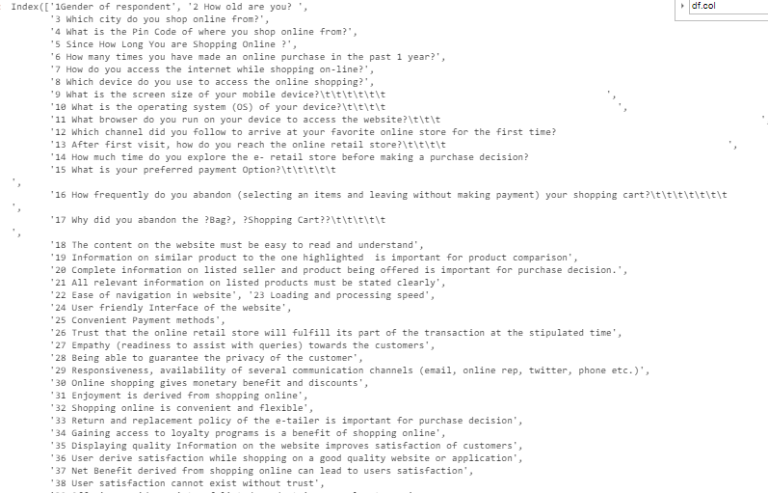

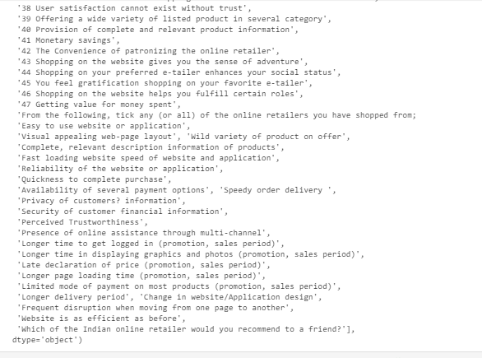

As we can see in the above screenshot, we have a long list of questions/features that we need to analyse in order to understand better our data and its pattern.

First, we check the data shape of our data:

* Data shape:

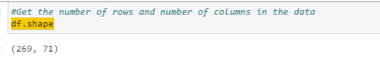

We see the data has 269 rows and 71 columns including our target column.

* Data Sources and their formats:

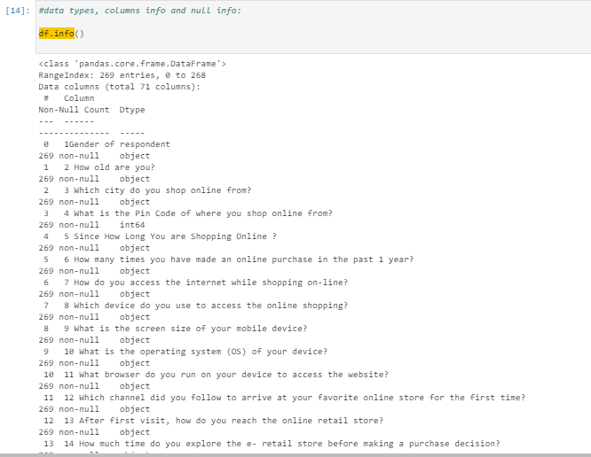

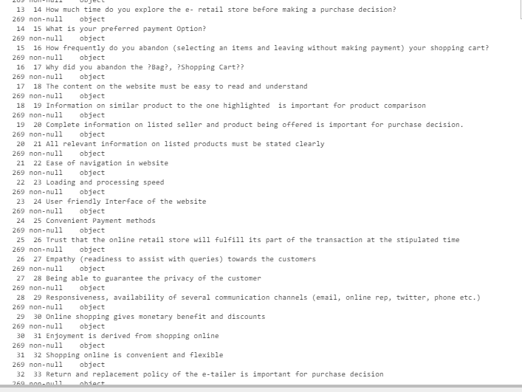

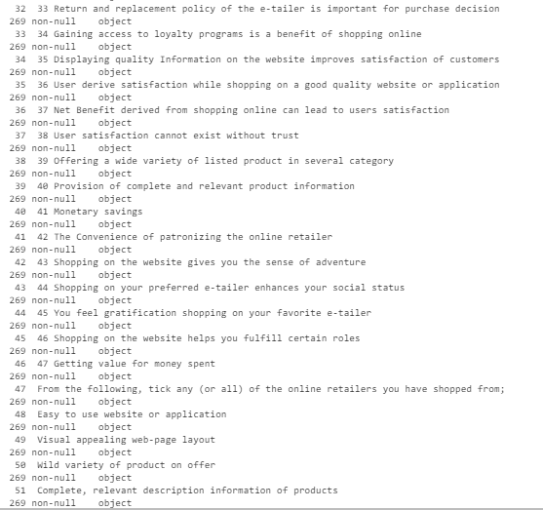

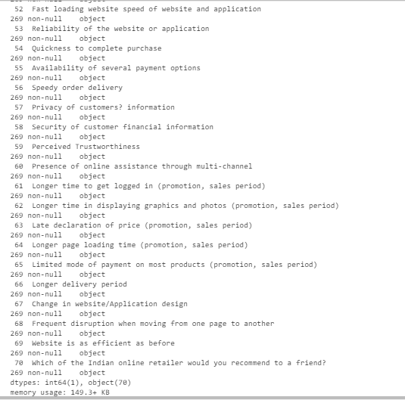

The data was given in the ziP format file and attached to the study case. As we said, in the dataset we have a total of 269 rows and 71 columns. Checking the data types, we have a total of 1 integer as numerical features and 70 features as object type.

So, for our analysis, throughout the process, we reconverted the type of data we have in order to analyse it more in detail. For example, we had to convert the features and encode them in order to add them in the machine learning algorithms.

Mostly all the features have object data type when in some cases should have been numerical float or integer data type. So, I needed to convert them to numerical for proper analysis and also for some statistical checks such as outliers.

* Data Preprocessing Done

The steps we followed for data processing and cleaning was to impute the missing values of the training set. But, surprisingly, there was no missing data, which is good and we do not need to impute the missing values.

* Data Inputs- Logic- Output Relationships

So, when we study the relationship between our features with regards our output target, we have several considerations to have in mind:

* + First of all, the data format of the input and output:
    - As we said, we had several different formats of our input data such as integer and object.
    - Regarding the integer data type, there was no such issue as these were already numerical type data.
    - The problem was basically with other object type data when considering them for the relationship purposes. And for these, we had to label encode them in order to convert them in the right format for the correlation studies.
  + Relation and affection between the input and output:
    - When checking the relationships between the features and the target, we see some feature like listed below which have highest correlation with regards our target variable Customer recommendation for purchase or re-purchase:

For example:

Complete, relevant description information of products +0.680926

Reliability of the website or application +0.542711

Easy to use website or application +0.541713

Presence of online assistance through multi-channel +0.503836

Perceived Trustworthiness +0.483457

17 Why did you abandon the ?Bag?, ?Shopping Cart??\t\t\t\t\t +0.448997

Longer delivery period +0.428419

Change in website/Application design +0.423877

Availability of several payment options +0.416729

Quickness to complete purchase +0.398754

Fast loading website speed of website and application +0.335192

And the following are the features with highest correlation with regards our target from the negative side:

18 The content on the website must be easy to read and understand -0.349016

28 Being able to guarantee the privacy of the customer -0.358734

21 All relevant information on listed products must be stated clearly -0.362879

34 Gaining access to loyalty programs is a benefit of shopping online -0.400583

31 Enjoyment is derived from shopping online -0.436613

See screenshot below for all correlations:

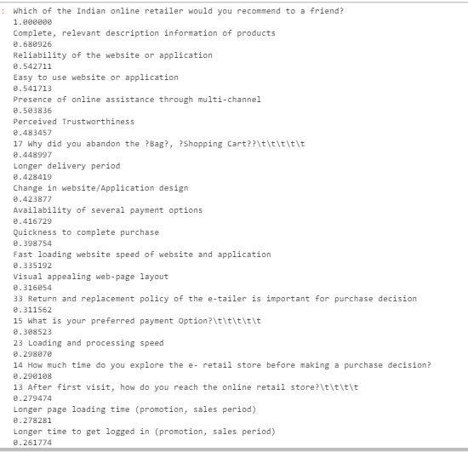

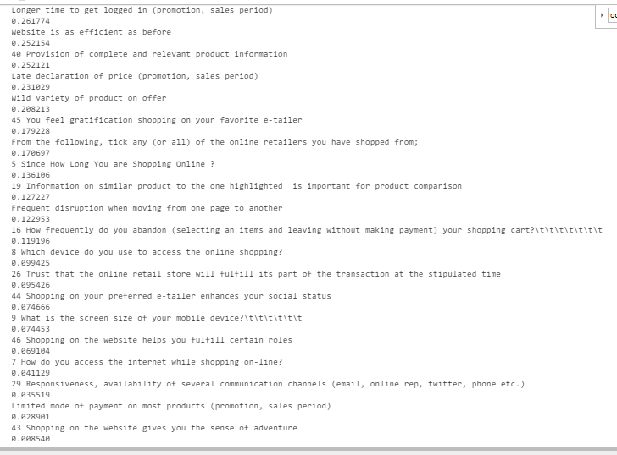

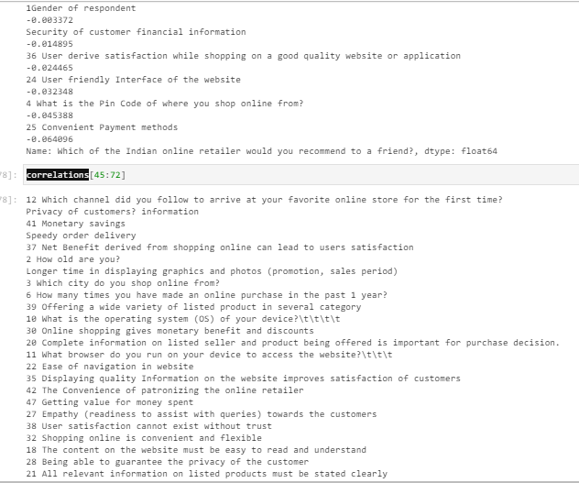

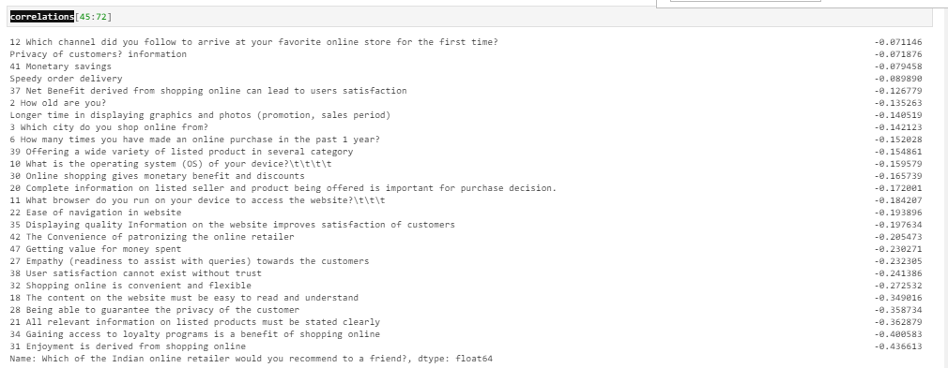

And the least important correlations are the one near to 0 which are the following:

8 Which device do you use to access the online shopping? +0.099425

26 Trust that the online retail store will fulfill its part of the transaction at the stipulated time 0.095426

44 Shopping on your preferred e-tailer enhances your social status 0.074666

9 What is the screen size of your mobile device?\t\t\t\t\t\t 0.074453

46 Shopping on the website helps you fulfill certain roles 0.069104

7 How do you access the internet while shopping on-line? 0.041129

29 Responsiveness, availability of several communication channels (email, online rep, twitter, phone etc)0.035519

Limited mode of payment on most products (promotion, sales period) 0.028901

43 Shopping on the website gives you the sense of adventure 0.008540

1Gender of respondent -0.003372

Security of customer financial information -0.014895

36 User derive satisfaction while shopping on a good quality website or application -0.024465

24 User friendly Interface of the website -0.032348

4 What is the Pin Code of where you shop online from? -0.045388

25 Convenient Payment methods -0.064096

12 Which channel did you follow to arrive at your favorite online store for the first time? -0.071146

Privacy of customers? information -0.071876

41 Monetary savings -0.079458

Speedy order delivery -0.089890

37 Net Benefit derived from shopping online can lead to users satisfaction -0.126779

2 How old are you? -0.135263

Longer time in displaying graphics and photos (promotion, sales period) -0.140519

3 Which city do you shop online from? -0.142123

6 How many times you have made an online purchase in the past 1 year? -0.152028

39 Offering a wide variety of listed product in several category -0.154861

10 What is the operating system (OS) of your device?\t\t\t\t -0.159579

30 Online shopping gives monetary benefit and discounts -0.165739

20 Complete information on listed seller and product being offered is important for purchase decision. -0.172001

11 What browser do you run on your device to access the website?\t\t\t -0.184207

22 Ease of navigation in website -0.193896

35 Displaying quality Information on the website improves satisfaction of customers -0.197634

* Hardware and Software Requirements and Tools Used

I used Jupyter-notebook and Python 3 language.

Imported required libraries such as:

- pandas

- numpy

- matplotlib.pyplot

- seaborn

- sklearn

Also did import warnings in order to ignore them:

import warnings

warnings.filterwarnings('ignore')

And also imported pickle for the model saving.

**Model/s Development and Evaluation – I deleted the model development part as I could not load the the whole python code to github in just one python file.**

**Only included Analytical section as required.**

* So here we go with EDA including some visualization plots:

First of all, we plotted the missing values to check if we were missing any at this stage.

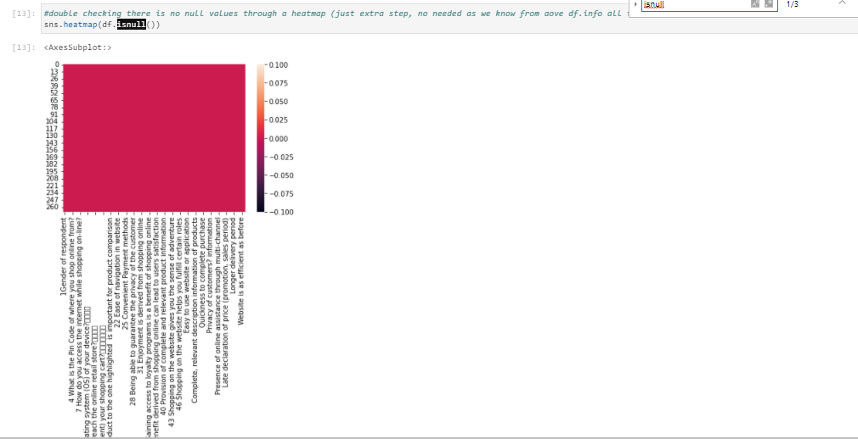

At this stage we checked and confirmed there is no missing values left.

Also, the same can we verified through the following check of null values:

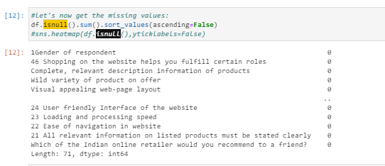

As we can see above, no null values are encountered as we see 0 values starting from the first row when sorting and apply the ascending=False.

After checking and making sure no missing values was there in our dataset, then we checked the unique values for each single feature column of our data and found:

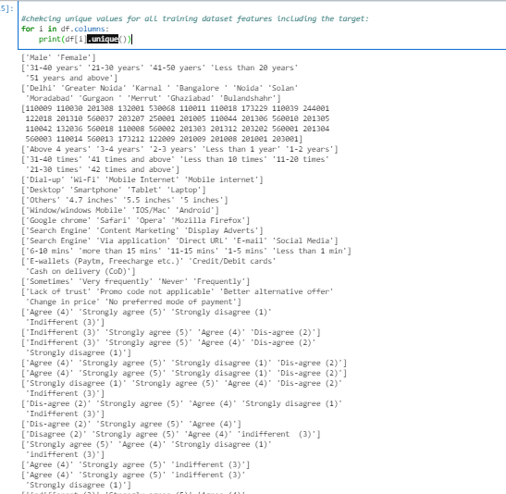

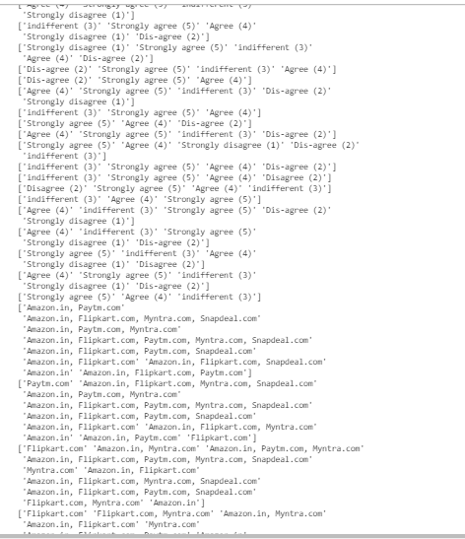

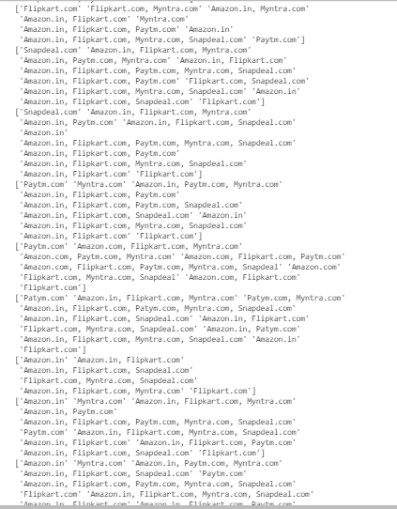

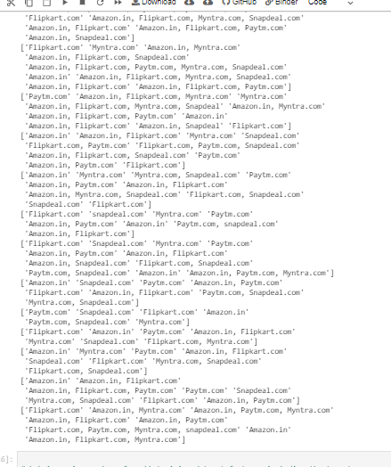

And checking the counts of total unique values for each column, we found:

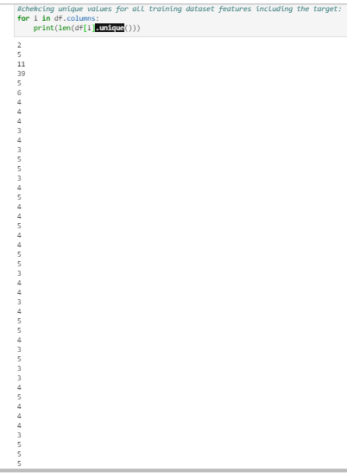

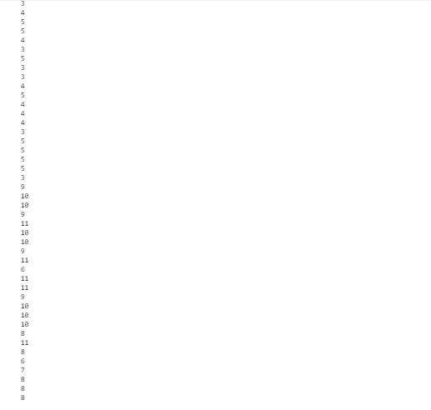

Quitar dos lineas de comments aqui

Printing the totals of unique values together with their corresponding names, we have: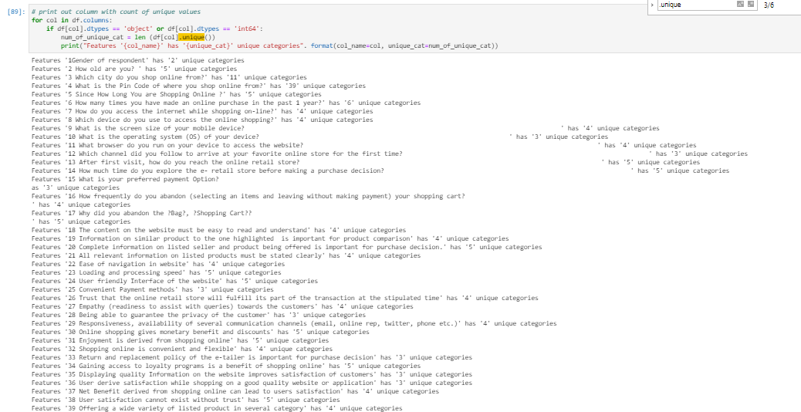

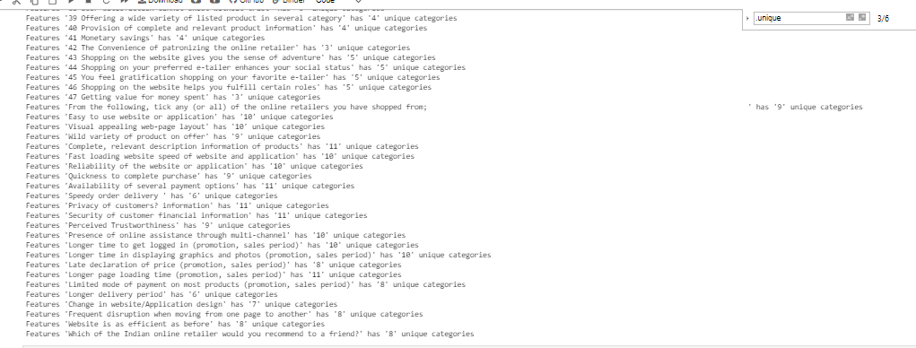

Hence, as the highlighted features we can comment the following:

* Categorical column like 1Gender of respondent' only has '2' unique categories to select from.
* We also have features like “ What is the Pin Code of where you shop online from?” which has 39 unique values and this feature has the most unique values compared to others features.
* When checking the remaining features, we can see we have categorical columns with different ranges of unique values such as:
  + Columns that have unique values between 3 and 6 categories which are the following ones:
    - Feature '2 How old are you? ' has '5' unique categories
    - Feature '5 Since How Long You are Shopping Online ?' has '5' unique categories
    - Feature '6 How many times you have made an online purchase in the past 1 year?' has '6' unique categories
    - Feature '7 How do you access the internet while shopping on-line?' has '4' unique categories
    - Feature '8 Which device do you use to access the online shopping?' has '4' unique categories
    - Feature '9 What is the screen size of your mobile device?' has '4' unique categories
    - Feature '10 What is the operating system (OS) of your device? ' has '3' unique categories
    - Feature '11 What browser do you run on your device to access the website? ' has '4' unique categories
    - Feature '12 Which channel did you follow to arrive at your favorite online store for the first time? ' has '3' unique categories
    - Feature '13 After first visit, how do you reach the online retail store? ' has '5' unique categories
    - Feature '14 How much time do you explore the e- retail store before making a purchase decision? ' has '5' unique categories
    - Feature '15 What is your preferred payment Option? ' has '3' unique categories
    - Feature '16 How frequently do you abandon (selecting an items and leaving without making payment) your shopping cart? ' has '4' unique categories
    - Feature '17 Why did you abandon the ?Bag?, ?Shopping Cart?? ' has '5' unique categories
    - Feature '18 The content on the website must be easy to read and understand' has '4' unique categories
    - Feature '19 Information on similar product to the one highlighted is important for product comparison' has '4' unique categories
    - Feature '20 Complete information on listed seller and product being offered is important for purchase decision.' has '5' unique categories
    - Feature '21 All relevant information on listed products must be stated clearly' has '4' unique categories
    - Feature '22 Ease of navigation in website' has '4' unique categories
    - Feature '23 Loading and processing speed' has '5' unique categories
    - Feature '24 User friendly Interface of the website' has '5' unique categories
    - Feature '25 Convenient Payment methods' has '3' unique categories
    - Feature '26 Trust that the online retail store will fulfill its part of the transaction at the stipulated time' has '4' unique categories
    - Feature '27 Empathy (readiness to assist with queries) towards the customers' has '4' unique categories
    - Feature '28 Being able to guarantee the privacy of the customer' has '3' unique categories
    - Feature '29 Responsiveness, availability of several communication channels (email, online rep, twitter, phone etc.)' has '4' unique categories
    - Feature '30 Online shopping gives monetary benefit and discounts' has '5' unique categories
    - Feature '31 Enjoyment is derived from shopping online' has '5' unique categories
    - Feature '32 Shopping online is convenient and flexible' has '4' unique categories
    - Feature '33 Return and replacement policy of the e-tailer is important for purchase decision' has '3' unique categories
    - Feature '34 Gaining access to loyalty programs is a benefit of shopping online' has '5' unique categories
    - Feature '35 Displaying quality Information on the website improves satisfaction of customers' has '3' unique categories
    - Feature '36 User derive satisfaction while shopping on a good quality website or application' has '3' unique categories
    - Feature '37 Net Benefit derived from shopping online can lead to users satisfaction' has '4' unique categories
    - Feature '38 User satisfaction cannot exist without trust' has '5' unique categories
    - Feature '39 Offering a wide variety of listed product in several category' has '4' unique categories
    - Feature '40 Provision of complete and relevant product information' has '4' unique categories
    - Feature '41 Monetary savings' has '4' unique categories
    - Feature '42 The Convenience of patronizing the online retailer' has '3' unique categories
    - Feature '43 Shopping on the website gives you the sense of adventure' has '5' unique categories
    - Feature '44 Shopping on your preferred e-tailer enhances your social status' has '5' unique categories
    - Feature '45 You feel gratification shopping on your favorite e-tailer' has '5' unique categories
    - Feature '46 Shopping on the website helps you fulfill certain roles' has '5' unique categories
    - Feature '47 Getting value for money spent' has '3' unique categories
    - Feature 'Speedy order delivery ' has '6' unique categories
    - Feature 'Longer delivery period' has '6' unique categories
  + Columns that have unique values between 7 and 11 categories which are the following ones:
    - Features '3 Which city do you shop online from?' has '11' unique categories.
    - Feature 'From the following, tick any (or all) of the online retailers you have shopped from; ' has '9' unique categories
    - Feature 'Easy to use website or application' has '10' unique categories
    - Feature 'Visual appealing web-page layout' has '10' unique categories
    - Feature 'Wild variety of product on offer' has '9' unique categories
    - Feature 'Complete, relevant description information of products' has '11' unique categories
    - Feature 'Fast loading website speed of website and application' has '10' unique categories
    - Feature 'Reliability of the website or application' has '10' unique categories
    - Feature 'Quickness to complete purchase' has '9' unique categories
    - Feature 'Availability of several payment options' has '11' unique categories
    - Feature 'Privacy of customers? information' has '11' unique categories
    - Feature 'Security of customer financial information' has '11' unique categories
    - Feature 'Perceived Trustworthiness' has '9' unique categories
    - Feature 'Presence of online assistance through multi-channel' has '10' unique categories
    - Feature 'Longer time to get logged in (promotion, sales period)' has '10' unique categories
    - Feature 'Longer time in displaying graphics and photos (promotion, sales period)' has '10' unique categories
    - Feature 'Late declaration of price (promotion, sales period)' has '8' unique categories
    - Feature 'Longer page loading time (promotion, sales period)' has '11' unique categories
    - Feature 'Limited mode of payment on most products (promotion, sales period)' has '8' unique categories
    - Feature 'Change in website/Application design' has '7' unique categories
    - Feature 'Frequent disruption when moving from one page to another' has '8' unique categories
    - Feature 'Website is as efficient as before' has '8' unique categories
    - Feature 'Which of the Indian online retailer would you recommend to a friend?' has '8' unique categories

In summary we have different ranges of unique values including columns with just 2 unique values and columns that have unique values between 3 and 11 and also features alongside with a feature pin code which includes 39 unique values.

When checking our target unique values, we can comment and highlight the following:

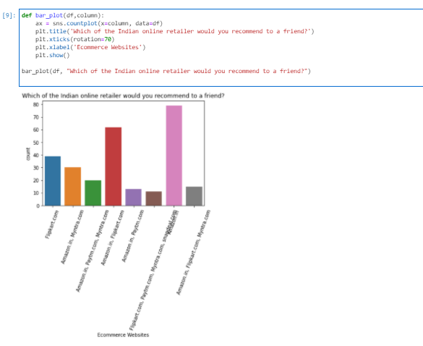

In the Barplot we can easily see that one category includes all ecommerce names and has the most voting as shown in the above plot.

One of the main reason of such difference can be that sometimes the customer cannot decide which online ecommerce is the better one among all the options and cannot compare and decide which one is the best one when comparing between the best options and having into account all the important features of an online commerce website for a customer.

Then, the second most voted category is the category which includes ecommerce brand groups like Amazon, Paytm and Myntra as the triple combo.

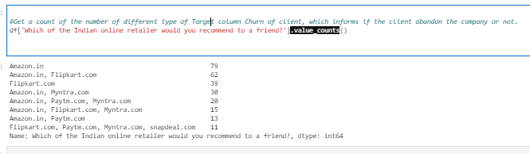

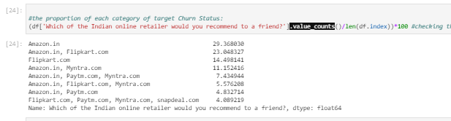

Then, when we check the above absolute and relative values with regards our target feature column named 'Which of the Indian online retailer would you recommend to a friend?', we can see that the most preferable ecommerce when comparing the single ecommerce categories is Amazon and Flipkart. Alongside with Amazon, which is obvious and clear to understand from the actual ecommerce market , we can see we have website Flipkart is the ecommerce website where customers prefer to go as second preferred website when comparing the absolute and relative percentages. In the above absolute and relative list, we can see Amazon takes the first place as the most recommended website for electronic commerce purposes which has a value count of 79 cases and which takes 29,36% of the total cake of the categories included in our data. 79 cases has voted Amazon as the best and recommended ecommerce to go for online shopping.

Then, after Amazon, when checking the value counts, we see we have Amazon and Flipkart as the best combination that takes 2nd place when choosing for recommended ecommerce websites.

So, after Amazon, Flipkart would take the next second position when shopping online.

Again, we can see and be sure about Flipkart being the second most preferred or recommended website to go as it keeps appearing in third position, this time as single website not a combo.

The last approach we can also see in the pie chart which has Amazon and Flipkart with highest percentage of recommendation chances:

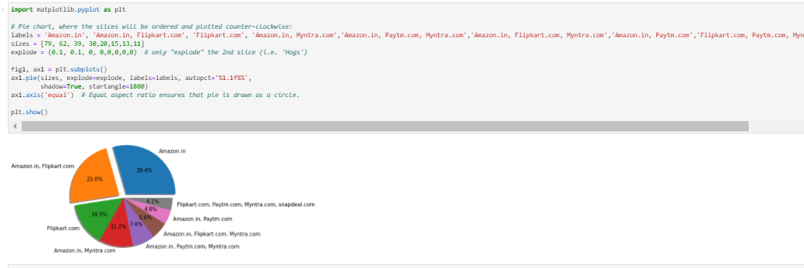

We can see Amazon is the highest recommended ecommerce website with a recommendation percentage of 29, 4% as mentioned previously in the relative value_counts when comparing to others available categories included in our data. Then, as we said, Flipkart goes in second place in the pie chart where we can also see the Flipkart and Amazon is the best combo and takes the second place and Flipkart takes the 3rd place as single brand for online purchase order and it takes around 14’5% of the total proportion of the voting done in our ecommerce available dataset.

Now, let’s check the different unique values total counts through barplot for the remaining features:

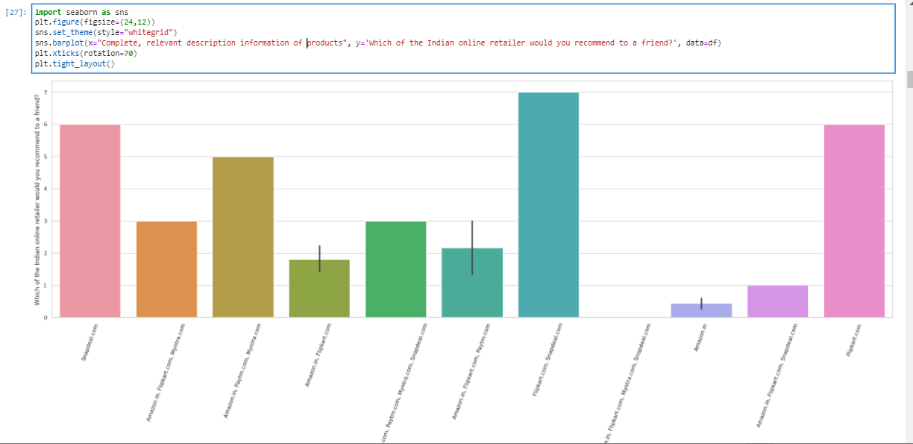

So, first of all, checking the ‘Complete, relevant description information of products’ with regards our target variable ‘Which of the Indian online retailer would you recommend to a friend?’ we can easily see the Flipkart and Snapdeal wins the first position as the most voted ecommerce brands who have the best complete, relevant descriptive information of their products.

Next, we will check barplot of Reliability of the website or application and compare it with our target variable:

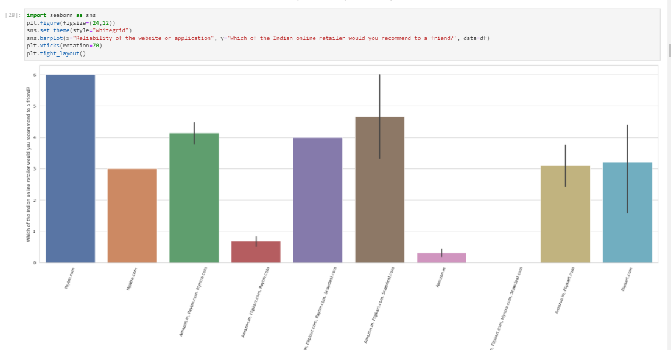

We can see that Paytm wins this comparison as it is in the first position when comparing the recommended websites through “Reliability of the website or application”.

After Paytm, we can also mention that combo of Amazon, Flipkart and Sanpdeal wins the second position followed by combo of Amazon, Paytm and Myntra which is at third place and has a very few cases more than combo Amazon,Flipkart,Paytm,Snapdeal.

And after that, comes in fifth place Flipkart that has a very few cases more than combo Amazon and Flipkart.

When checking the target by “Ease to use website or application", we can see the following barplot:

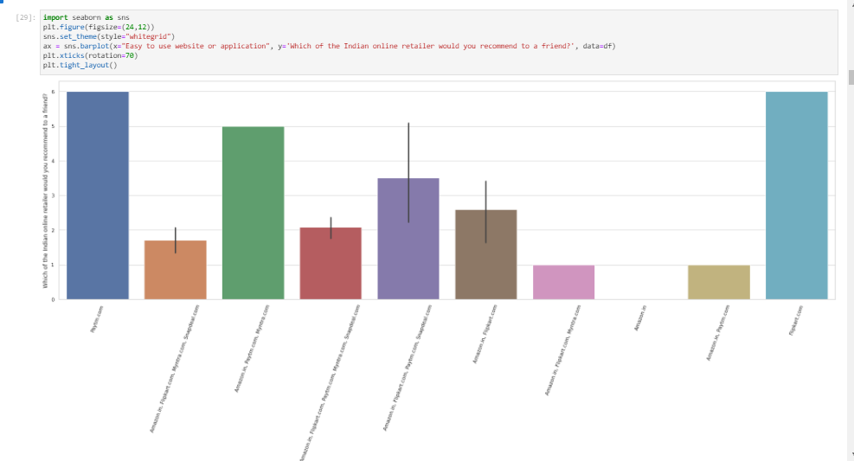

Here, we can highlight that Paytm and Flipkart wins the bet as being the most voted ecommerce website when taking in account the characteristic “Easy to use website or application".

After that, in second position, we have a combo of Aamazon, Paytm and Myntra.

Regarding the 2 minimum votes of recommendation compared to others are :

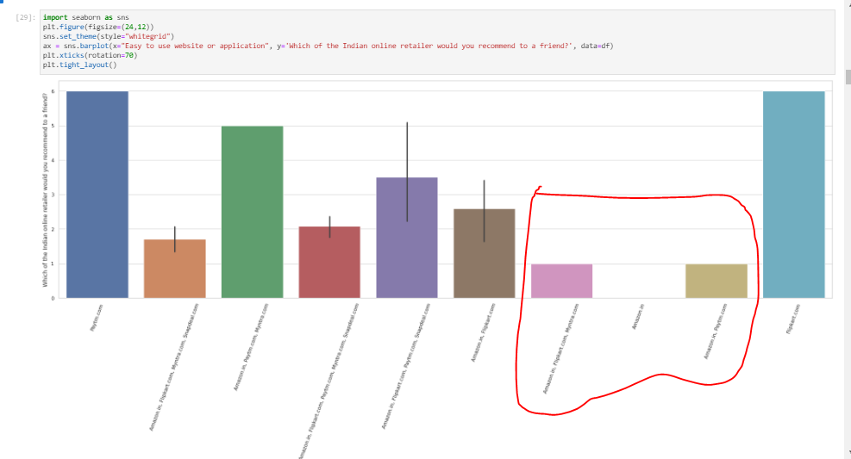

Combo of Amazon, Flipkart and Myntra and combo of Amazon and Paytm.

The worst as recommended website to go when comparing them through “Easy to use website or application" is Amazon. It’s understandable as they have a huge amount of data or products to offer and it is difficult to organize every single item of every single sector.

Next, we can see and compare our target feature of recommendation this time by “Presence of online assistance through multi-channel":

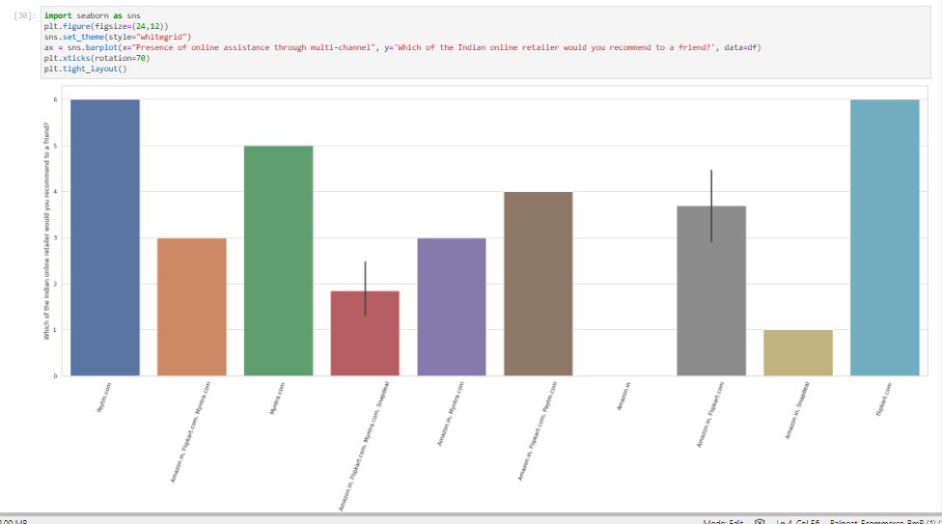

Here we can mention that again Paytm and Flipkart take the first place as single ecommerce website to go and then in second place we have Myntra which also has a good and noticeable cases where the customer chose Myntra over all others options.

Now let’s also check the customer recommendation by Perceived Trustworthiness of the website:

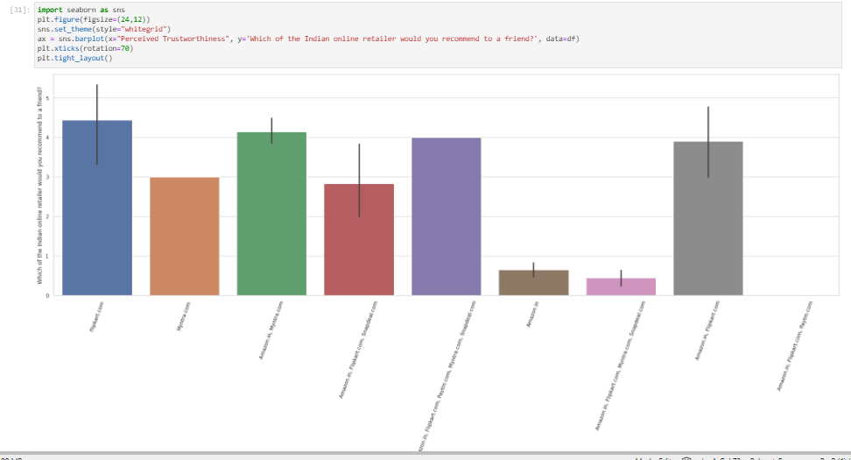

Here we can say that almost all the combos has the same or similar proportion of cases, at least it happens in the following cases:

* Flipkart takes the very first place.
* Then comes combo of Amazon and Myntra.
* Then, with very a few less cases comes the combo of all ecommerce websites.
* And with similar cases to the previous one, maybe one o couple of few cases, we have the combo of Amazon and Flipkart.
* Aand most importantly, the worst recommendation votes goes to Amazon and combo of Amazon, Flipkart, Myntra and Snapdeal.

Now, let’s go for and barplot the total of each unique value of ‘17 Why did you abandon the ?Bag?, ?Shopping Cart??\t\t\t\t\t ‘:

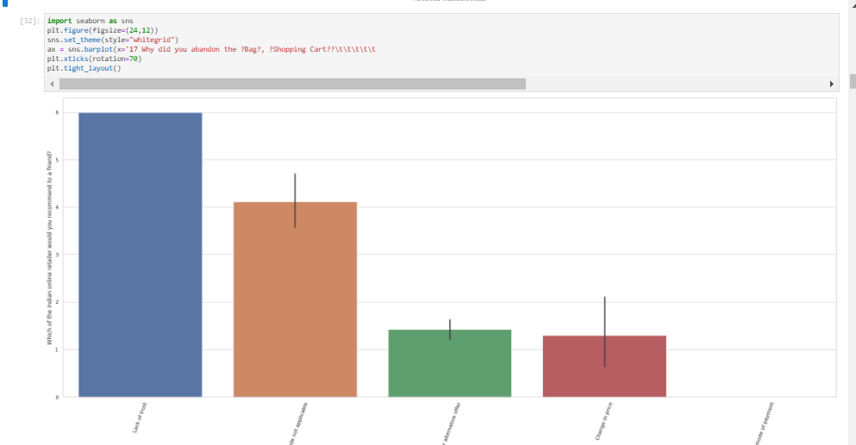

Here we can easily notice that the first position goes to “Lack of Trust” on the ecommerce website. So, which means the customer leaves the shopping cart without purchasing due to not having enough trust on the website from where the customer is doing the purchase order.

The second most voted reason behind the shopping cart leave is the “promo code not applicable”. So, here, this is also the reason due to what many of the customers leaves the shopping cart in the website without doing any purchase because the customer primarly came to the corresponding website in order to buy something with the promo code and take the advantage of the corresponding applicable discount.

The third and fourth reason of not purchasing the online cart are the change in price and when the customer finds better alternative offer for the same. These 2 reasons are way far to happen and has way less probabilities to happen than the first 2 main reasons.

And when the NO purchase the current shopping cart due to the mode of payment, if the customer has finally changed the decision and do not want to purchase cart we see no cases at least in our dataset where a customer has declined the shopping cart due to unavailability of the preferred payment mode. Which means, all the ecommerce website have all the payment options preferred by a customer.

Let’s now check our target variable taking into account the feature “Longer delivery period”:

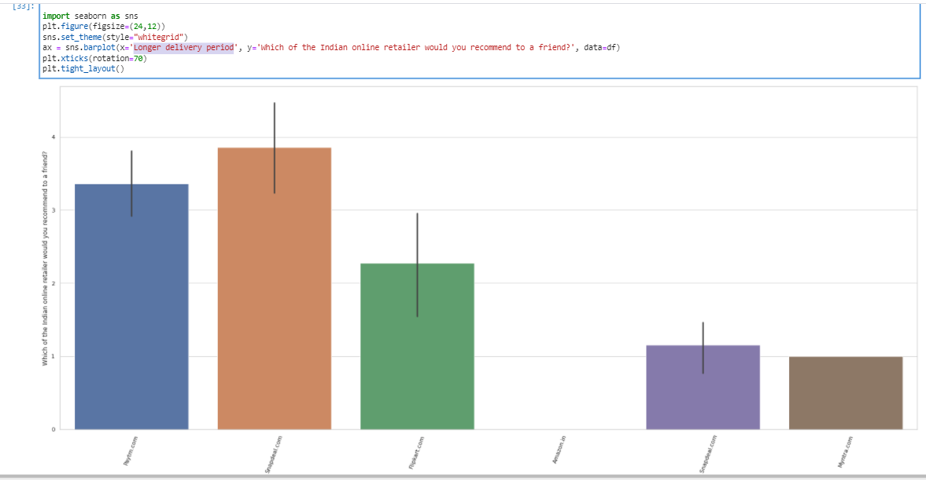

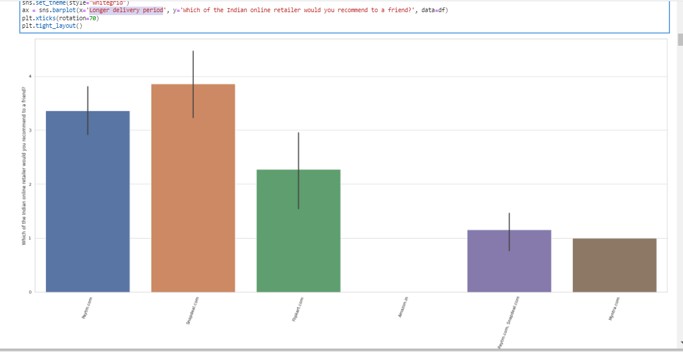

We see the Snapdeal is the most recommended when the delivery is longer than expected, which actually means, we should go for Snapdeal alongside with Pytm and Flipkart.

In the next plot, we can check a plot of website recommendation when we are comparing it through the comparison of ‘changes in website/Application design':

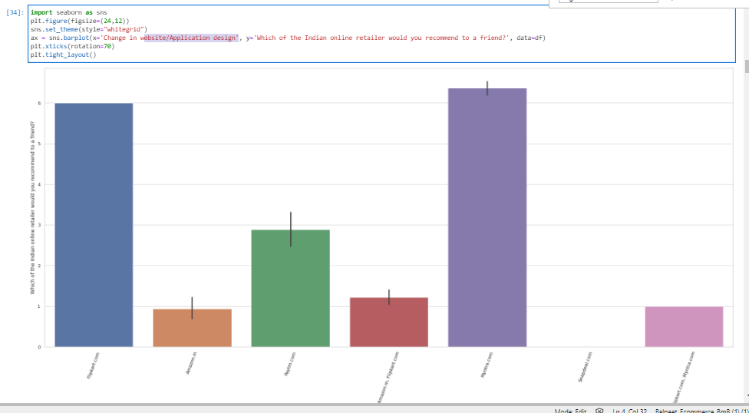

Throughout the previous plot, we can easily that Flipkart and Myntra stands out from the others as these 2 have gained more recommendation votes when comparison the recommendation votes by changes in website or app design.

Now let’s check the recomendaded website by avalaibility of several payment options:

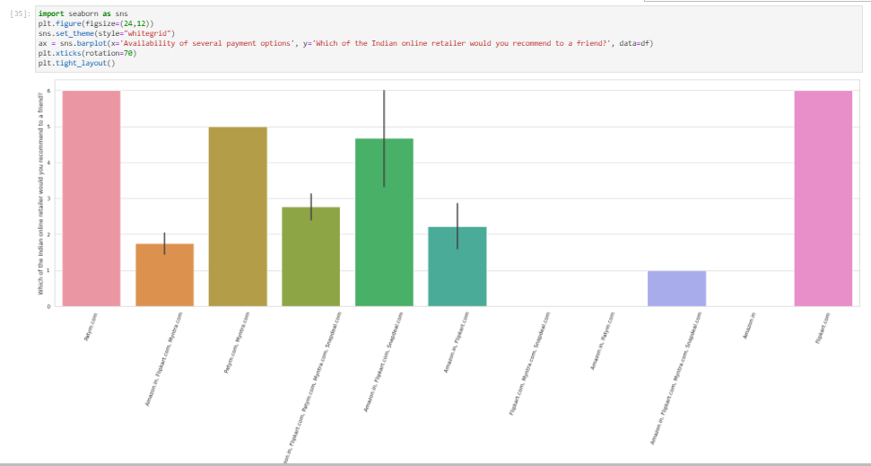

Now here we can highlight that Paytm and Flipkart wins the first position as per availability of different methods of payment.

Now it’s time to check the best or most recommended online ecommerce website when checking the feature 'Quickness to complete purchase':

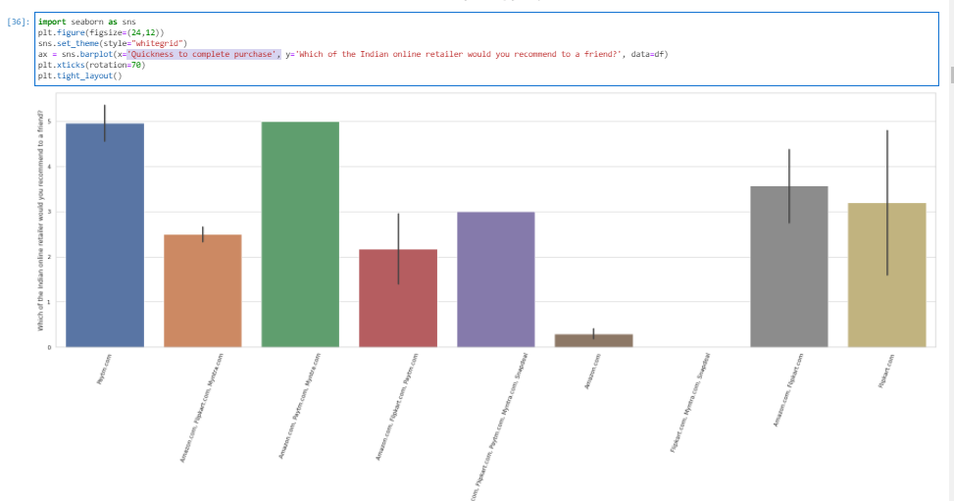

Even though there is no stand out categories of ecommerce websites, we can say that Pytm and combo of Amazon, Paytm and Myntra has gained the best position respectively.

Now let’s compare the best recommendation by Fast loading website, speed of website and application:

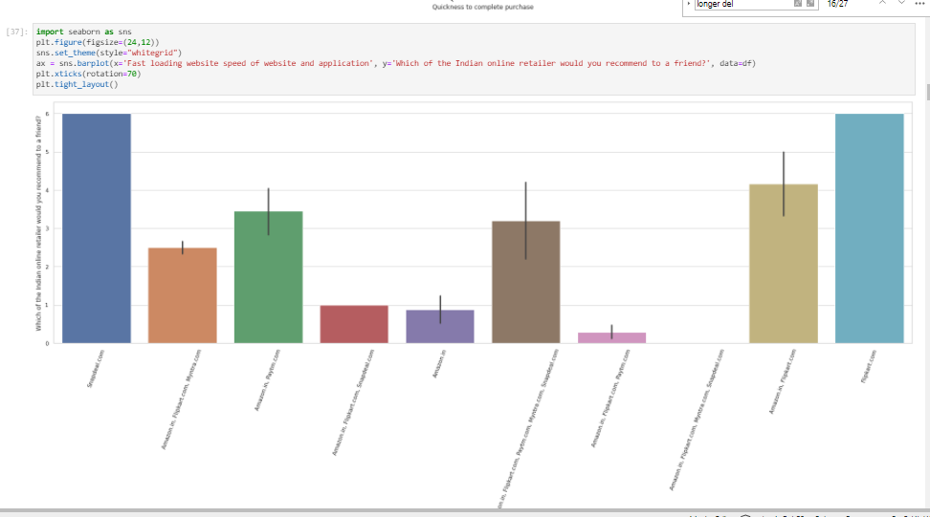

Now, we can say that Snapdeal and Flipkart are the most voted or most frequent case where the customer recommends these two when comparing the ecommerce websites by Fast loading website, speed of website and application. This should be because Snapdeal and Flipkart are the websites which have the fast loading website and application.

Now let’s compare the recommended websites by ‘Visual appealing web-page layout’:

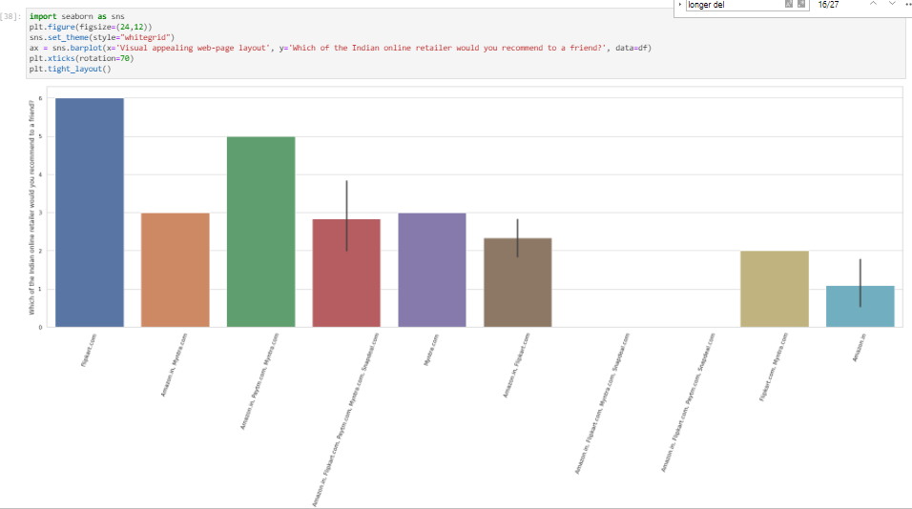

We can see in the above plot that Flipkart and combo of Amazon,Paytm or Myntra have the best appealing visuals for their website in comparison to others.

Now, let’s check the recommendation by Return and replace policy:

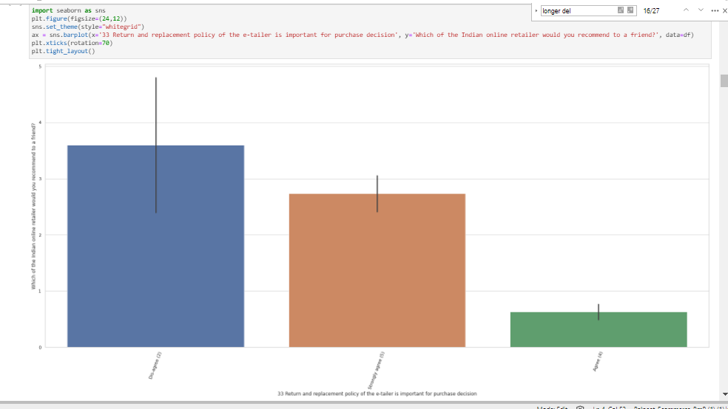

We see the most recommended website has often the case where the customer is not taking care of or does not gives much importance to return and replace policy when deciding for a purchase order.

We should also mention that we also have cases, less than the previous case, of people agreeing in checking the return and replace policy conditions before deciding for any purchase order.

Now, let’s go and evaluate the recommendation of the website by preferred payment method:

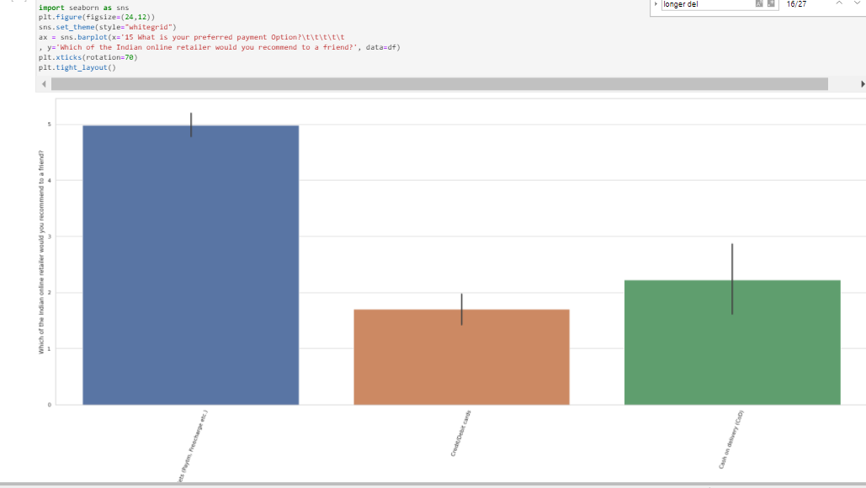

When comparing the preferred the payment method, we see the customers have decided to vote and recommend the combo of Ewallets like Paytm or Freecharge, etc.

Let’s now plot the recommended system by feature Loading and processing speed:

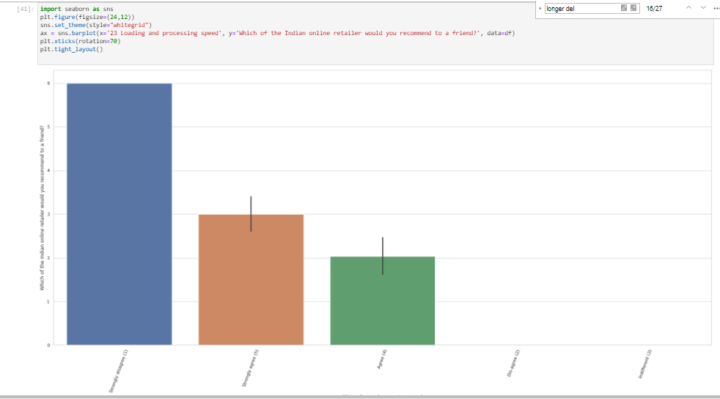

So, clearly we see that customer have voted more to “Strongly disagree” when comparing the loading and processing speed, which means the majority of the recommenders do not check and take into account the loading and processing sped when comparing and recommending the best ecommerce websites.

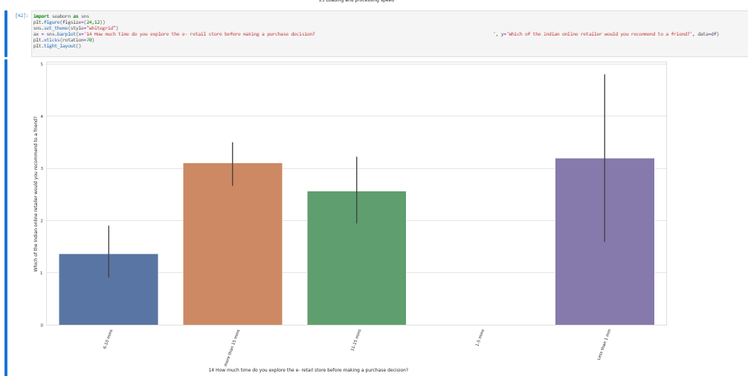

We see less than 1 min and more than 15 minutes are the options most voted.

This is due to when two completely different types of customers :

* The one who is checking overall every page in order to get the best.
* Then, the other one, that goes directly to the item he/she wants to purchase.

Now let’s try to understand how the customers get to the e-commerce retail store:

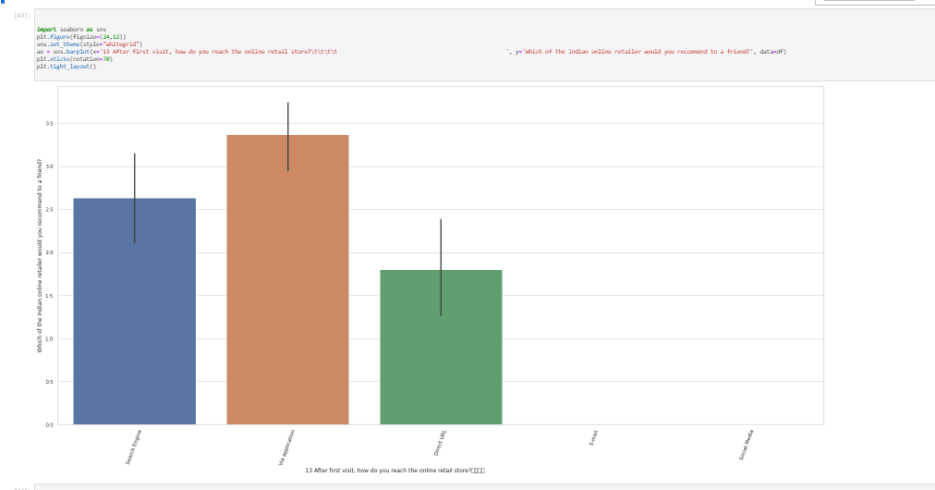

Okay, interesting is that more people go through the app more than searching through the search engine or direct URL.

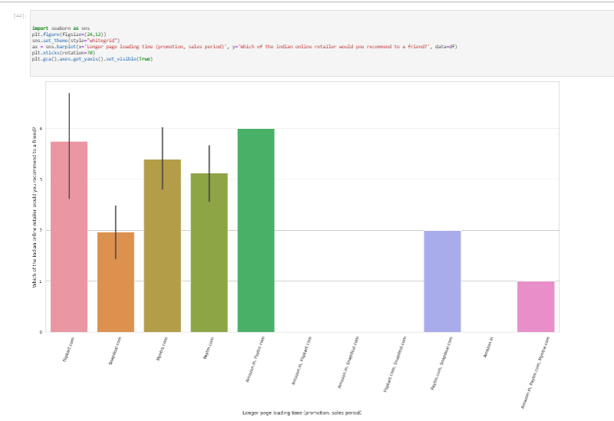

Okay, and when checking the page loading time when there are promotions or sales period, the customer recommended Flipkart and combo of Amazon and Flipkart. Obvious, these have large capacity to interchange data. No far away, we also see Myntra and Paytm.

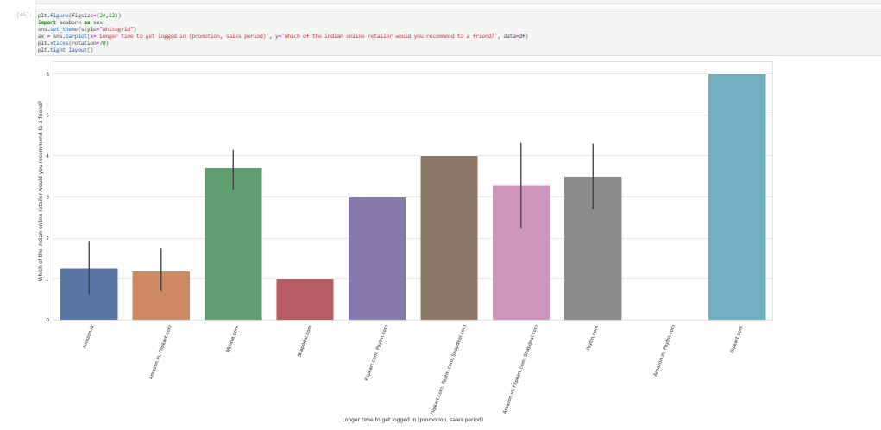

And regarding the logged in when having sales, we see the most recommended ecommerce retail is Flipkart sanding out from others ecommerce retails and even from the combos.

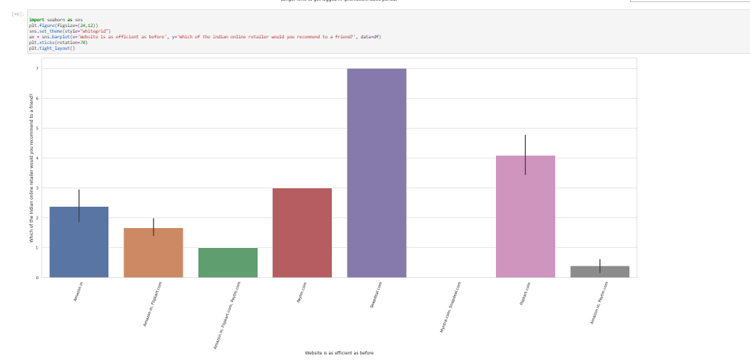

When checking the websites which have improved and are efficient as before, we see Snapdeal is the most voted for recommendation to a friend.

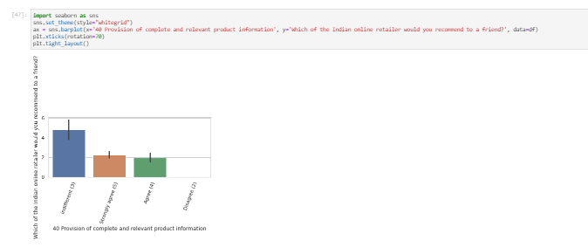

When comparing the websites recommendation by provision of complete and relevant producrt information, we see that mostly customers votes indifferent in most of the cases.

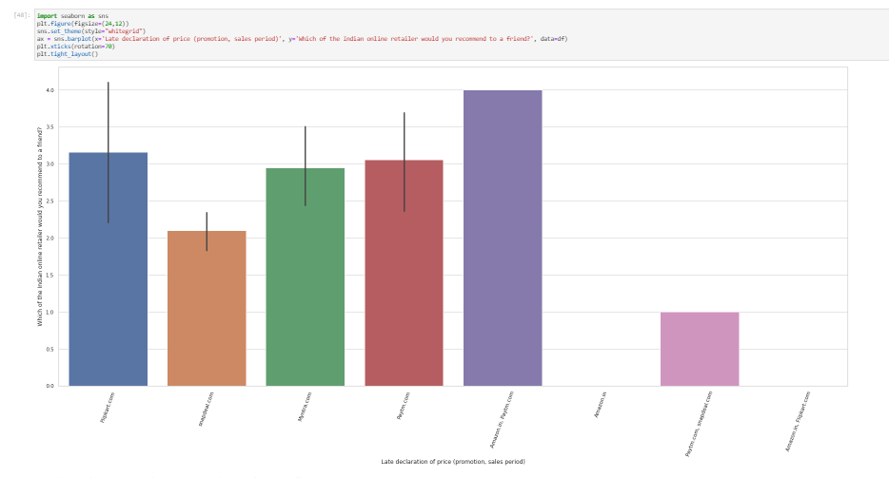

Now, finally, regarding the boxplot, we will comment this above one, which is the comparison of most recommended ecommerce websites by late declaration of price in promotion or sales period: And we see combo of Amazon and Paytm gets the first place, which means people tend to buy to these websites if they are comparing the feature late declaration of price in promotion or sales.

Now, let’s check for some value counts for the features that are most correlated with the target feature:

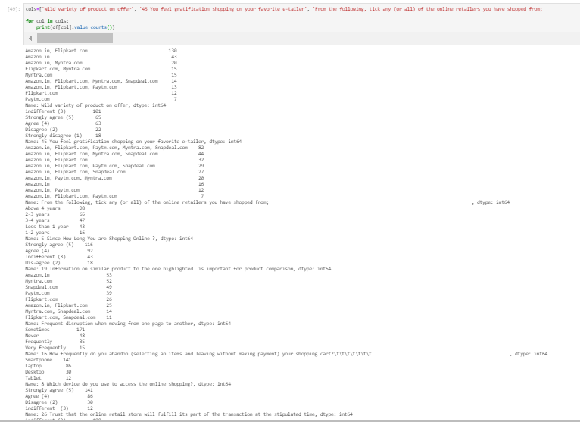

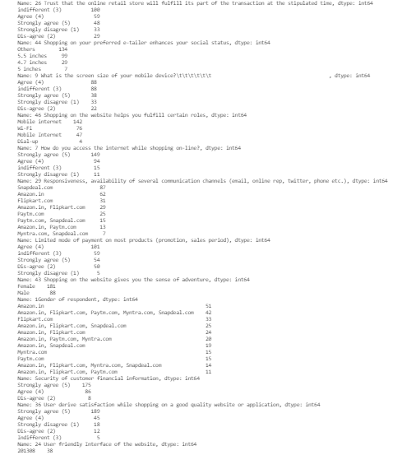

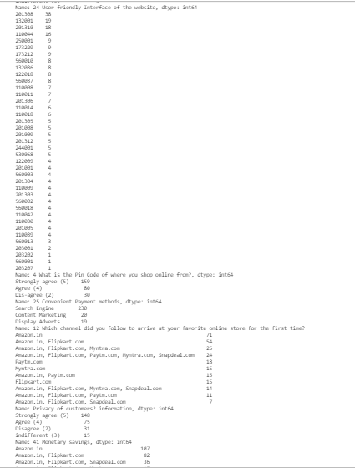

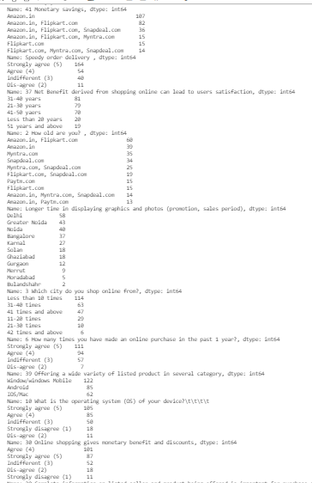

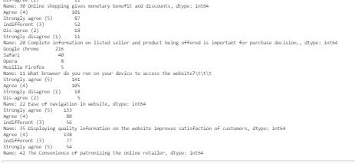

From the above total counts of unique values, we can highlight the following:

* We can see combo of Amazon and Flipkart gets the first place and Paytm gets the last place when checking the variety of product on offer.
* Mostly people do not feel gratified when shopping on their favorite e-tailer.
* From the ecomerce, people bought from all the mentioned ecommerce but mostly from Flipkart, Paytm and Myntra and Snapdeal, meaning from all the important websites.
* If we check the years the customers have been shopping on the ecommerce websites, we see that we have more customers who have been buying in the ecommerce websites for more than 4 years.
* We also can see that people prefer to have information on similar product to the one highlighted and it is important for products comparison.
* When checking and comparing the frequent disruption when moving from one page to another, we see the Amazon is in first place eventhough there is no such big difference between Amazon, Myntra and Snapdeal as can be seen below:

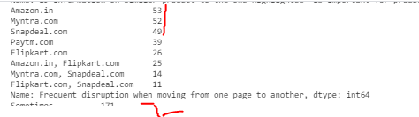

* Sometimes, customers may leave the shopping cart without doing any purchase order and paying it.
* Smartphones are the most frequent device used to access the online shopping.
* Mostly, the customers understand and trust that the online retail store will fullfill its part of the transaction at the stipulated time.
* People do not prefer to buy on their preferred etailer given the reason that it will enhances their social status.
* Mostly people use mobile internet to buy or access to the website while shopping online.
* Mostly people strongly agree to have responsiveness, availability of several communication channels (emails, online rep,twitter, phone, etc.)
* Mostly people find adventure looking for their products in the online tailer-store.
* In the most of the cases, we had Female who answered us the applied questions for us.
* Regarding the security of customer financial information, there is no such big difference but we can highlight that Amazon wins the bet in the first place.
* People strongly agree that there is a user derive satisfaction while shopping on a good quality website or app and also strongly agree that there should be a user friendly interface of the website.
* 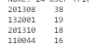these are the most used pin code of where the customer do shop online from.
* Most people strongly agree that there is a convenient payment method in the website.
* Okay, yes, so basically, as we can understand and be clear, the customers used search engine as the most used item in order to get at your favorite online store for the first time.
* Regarding the privacy of customers information, there is this GDPR for all international and national transactions where the GDPR is applied. The same happens with all the ecommerce websites. But, most frecuently, we see Amazon has the best and most frequently voted privacy of customers information security.
* Obviously, people go ahead with monetary savings when possible in case of same product or product with similar characteristics.
* Amazon wins as the fastest company when comparing the speed of order delivery.
* Obvious, people agree to have net benefit derived from shopping online and they agree that this net benefit can lead to user satisfaction.
* 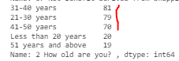 we can see the ages that buy most frecuently from the online stores are ages between 31 and 70.
* People tend to buy most frecuently less than 10 times a year but we also have considerable cases of customers who buy around 31 to 40 times a year from the online website.
* People strongly agree to have offered a wide variety of listed product in several category.
* Mostly, people use Windows operating system when doing the purchase.
* More than half of the proportion of the customers agree that they have online shopping where they can have a monetary benefit and discounts.
* More than half of the customers agree that complete information on the listed seller and product being offered is important for purchase decision.
* Google Chrome is the browser most used to access the website.
* Mostly people strongly agree or agree to have ease of navigation when using the website.
* People also accept to strongly agree to have displaying option for quality information on the website improves satisfaction of customers.
* And finally, people agree to have the convenience of patronizing the online retailer, interesting!

All the above comments can also be seen in the following boxplots:

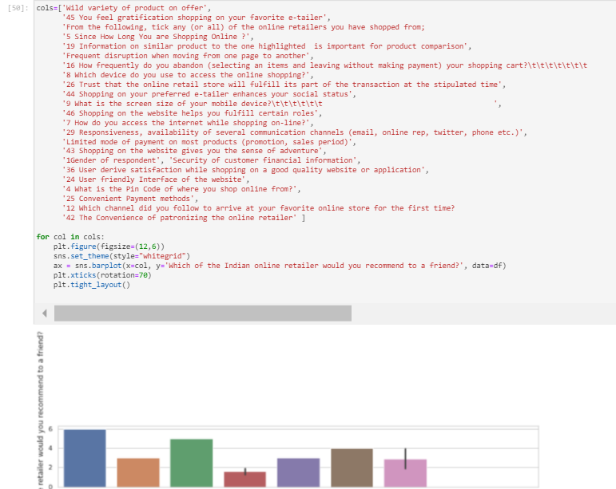

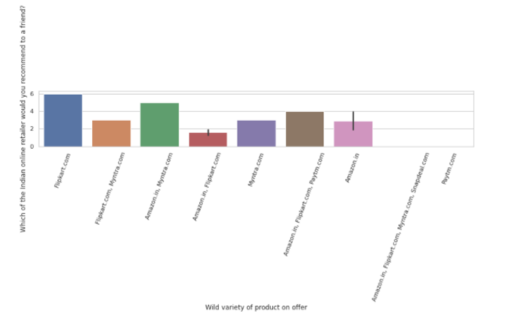

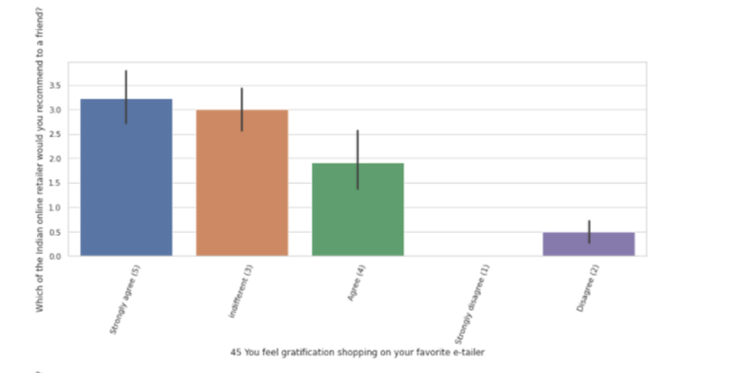

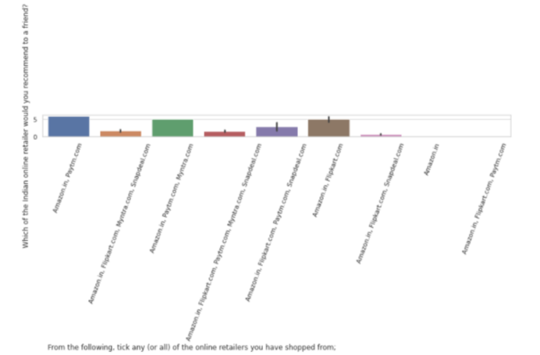

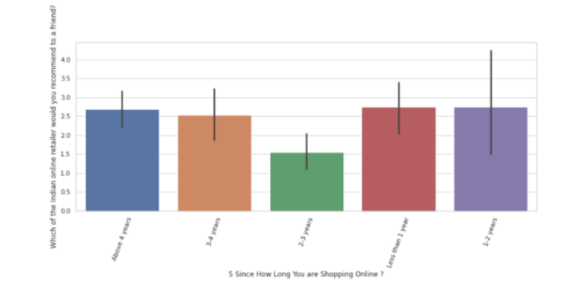

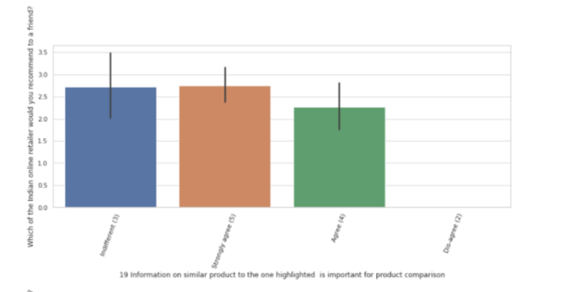

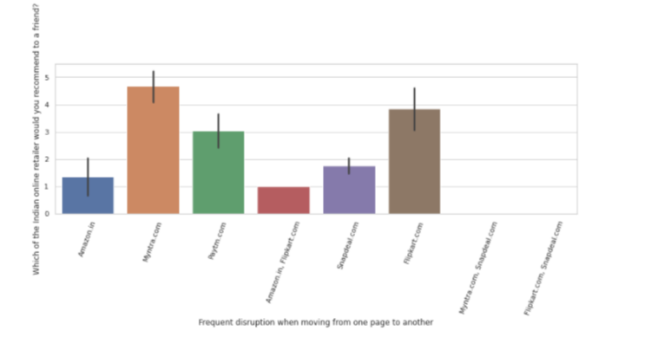

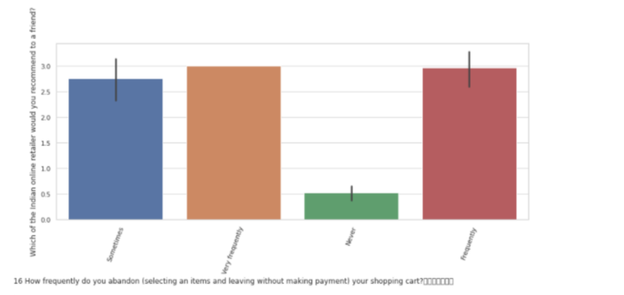

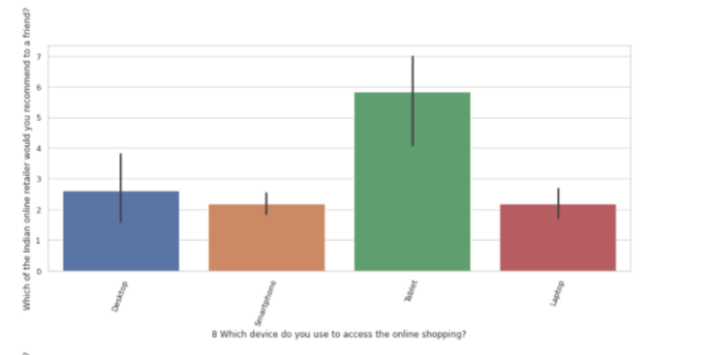

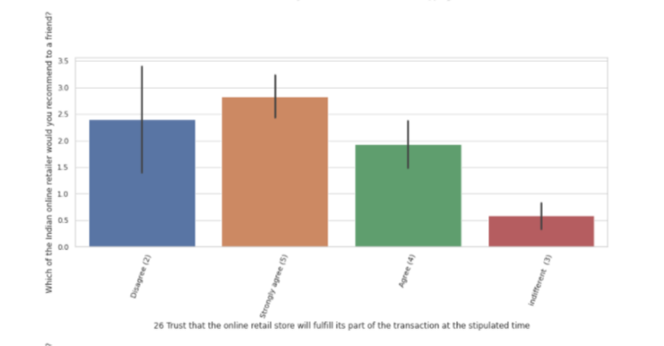

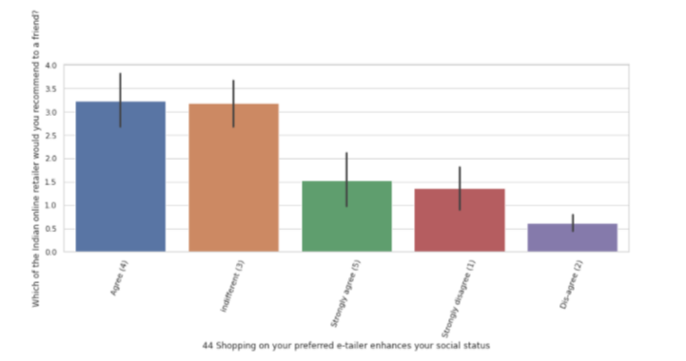

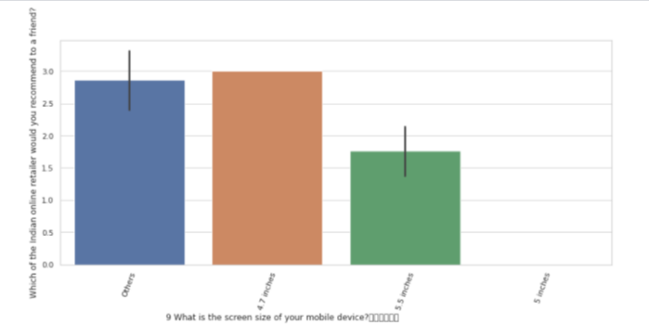

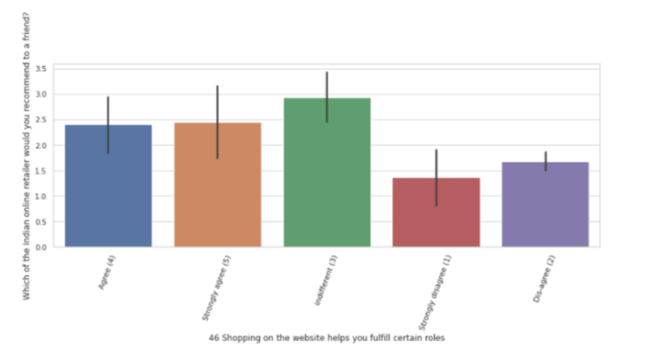

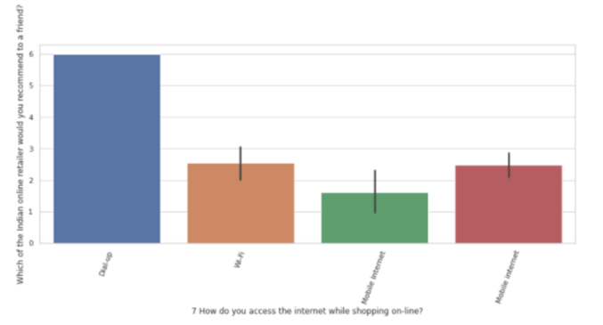

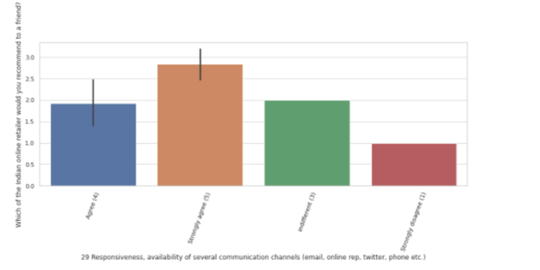

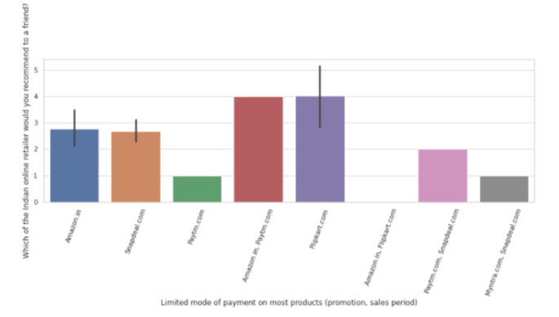

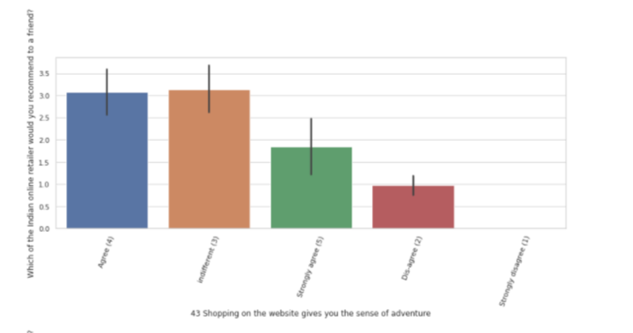

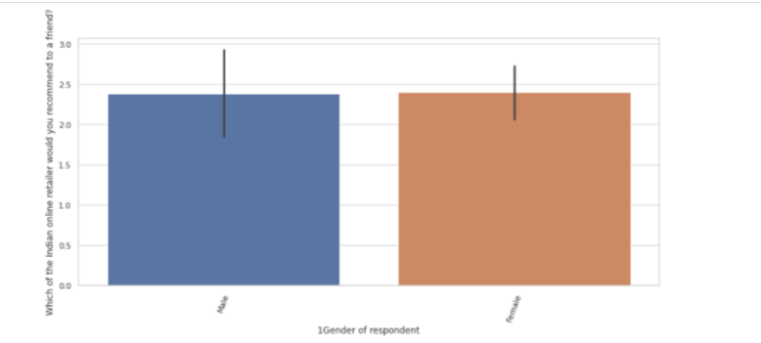

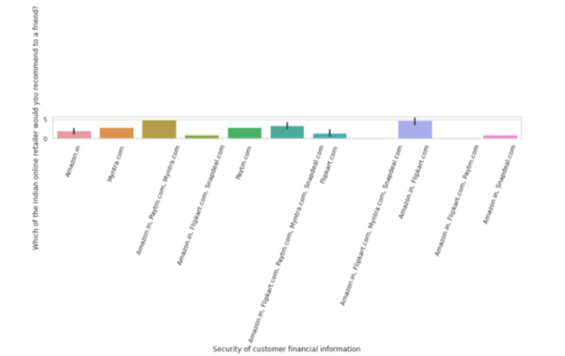

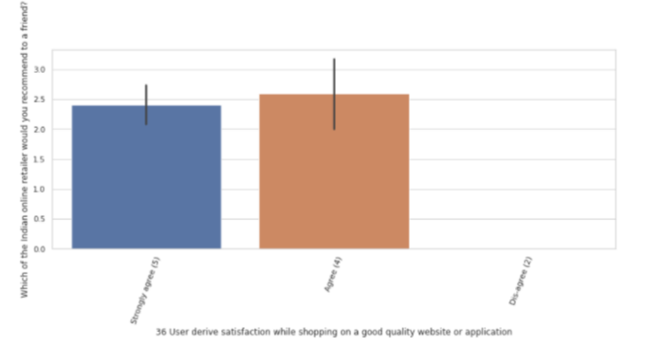

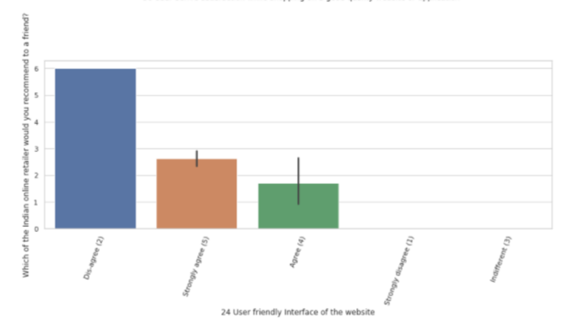

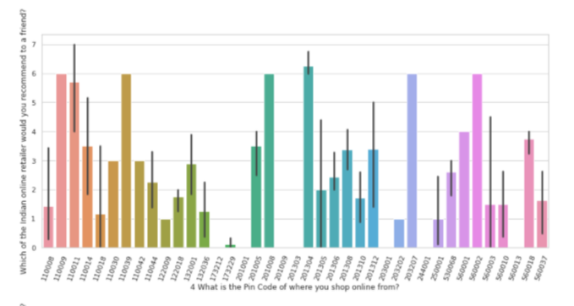

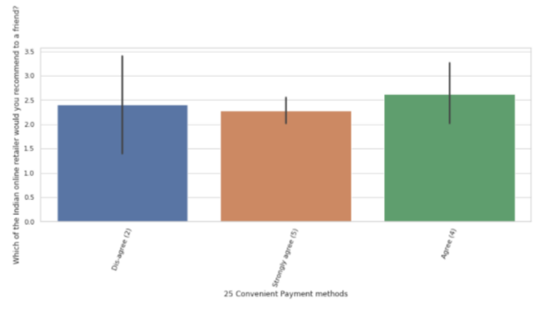

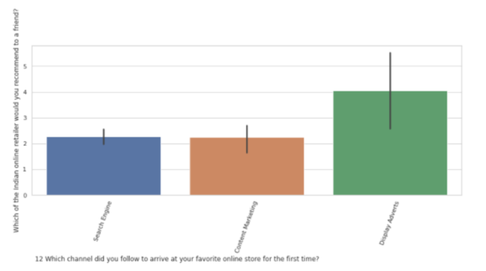

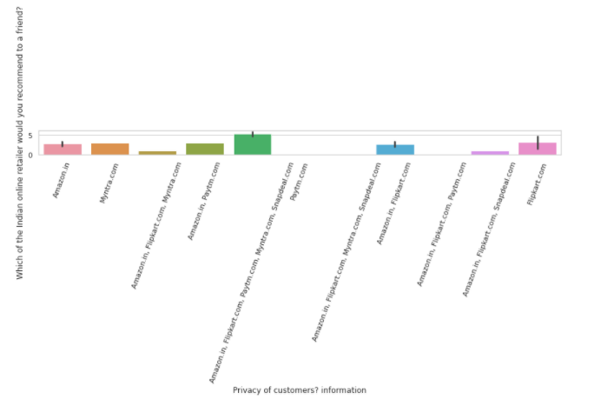

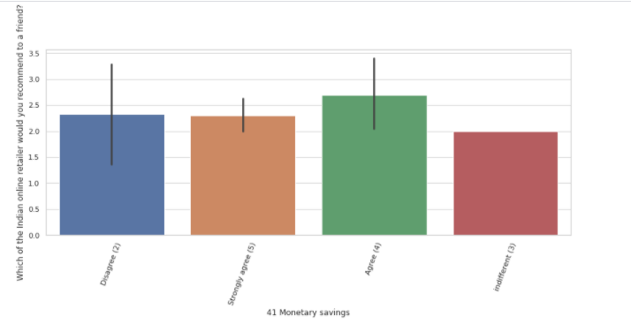

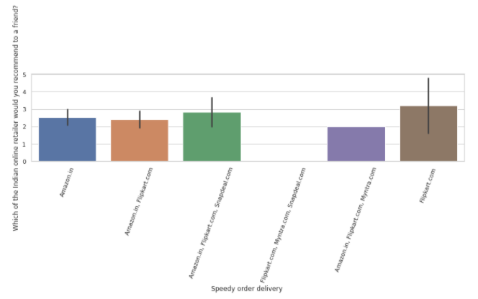

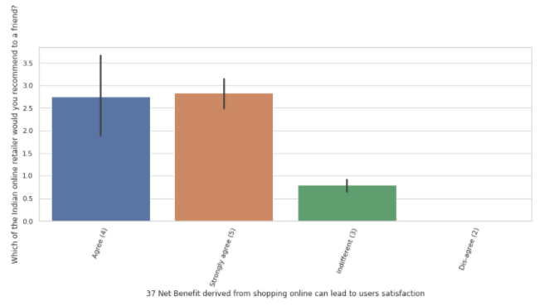

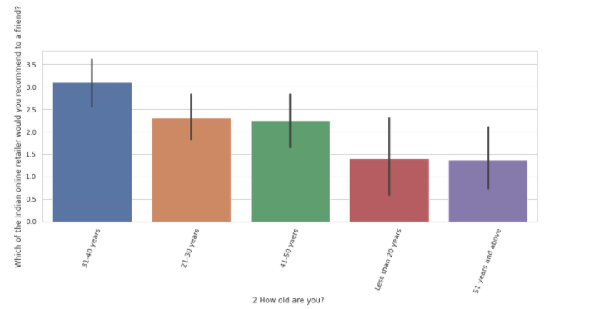

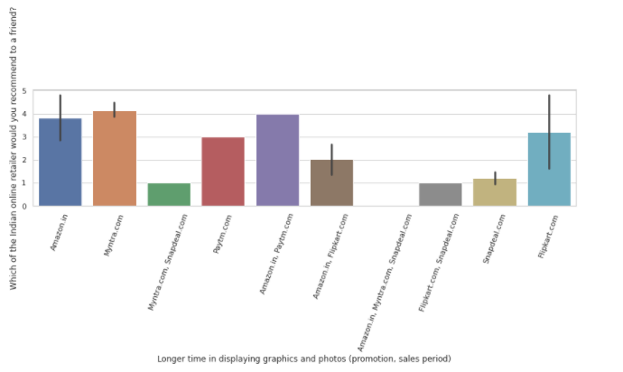

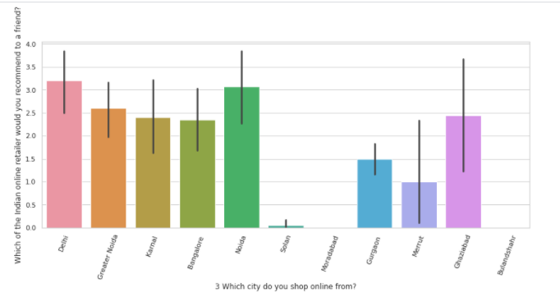

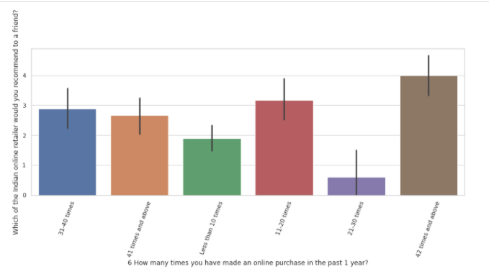

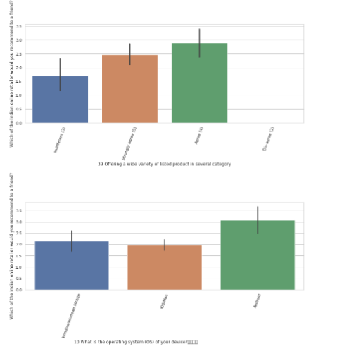

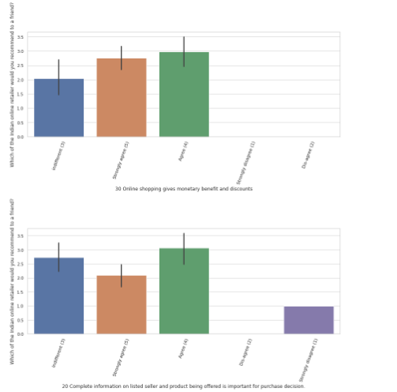

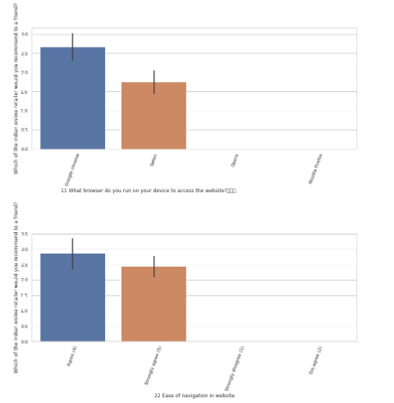

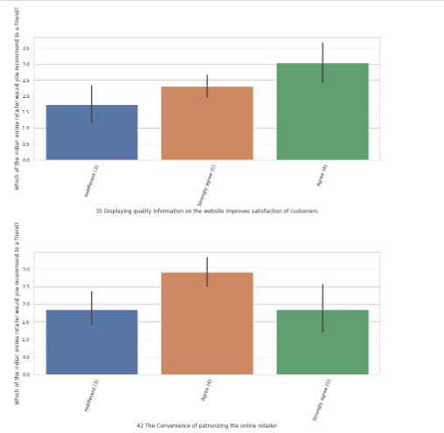

Now let’s study the unique categories for less important features than previous ones when correlating with our target variable:

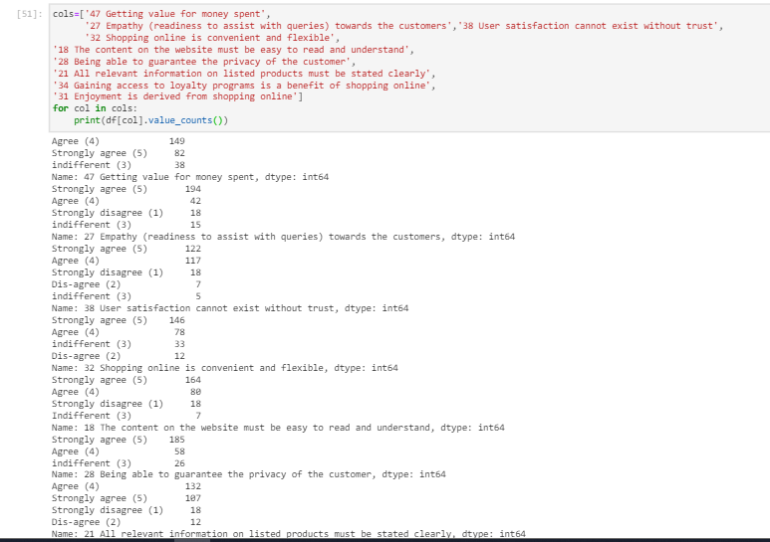

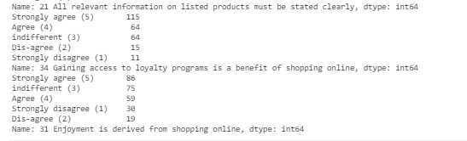

We agree that getting value for money spent is one of the main feature for a customer who is doing shopping on online website and we strongly agree that the ecommerce websites need to assist with queries of customers.

Most of the customers strongly agree that user satisfaction cannot exist without trust.

And there is no doubt that shopping online is convenient and flexible and the content on the website must be easy to read and understand and being able to guarantee the privacy of the customer.

Some people agree and others strongly agree that all relevant information on listed products must be stated clearly.

When talking about the loyalty, the customers strongly agree to gaining access to loyalty programs is a benefit of shopping online.

And more or less, more than half of the customers in our dataset confirms enjoyment is derived from online shopping. On the other hand, some of the customer also mention that there is no difference in having more enjoyment from the online shopping.

You can cross check the above comments against the below boxplot which are informing the same:

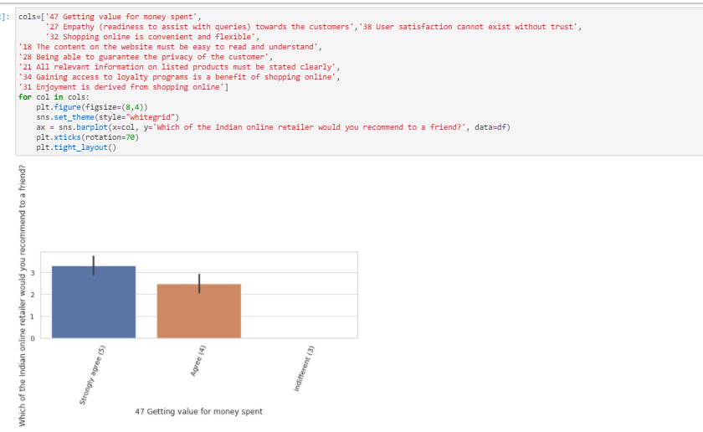

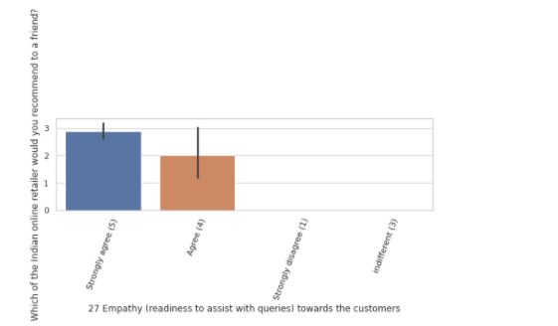

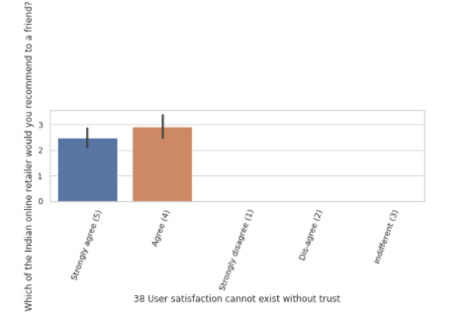

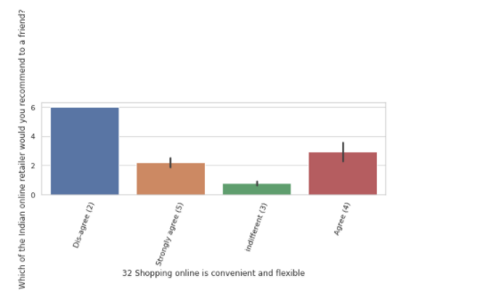

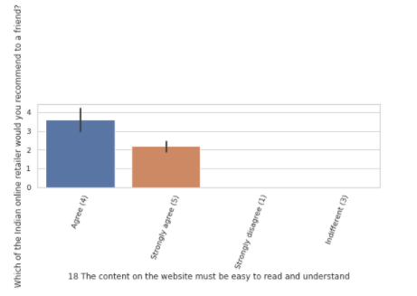

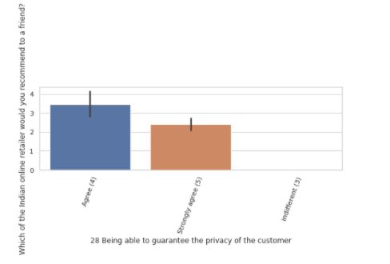

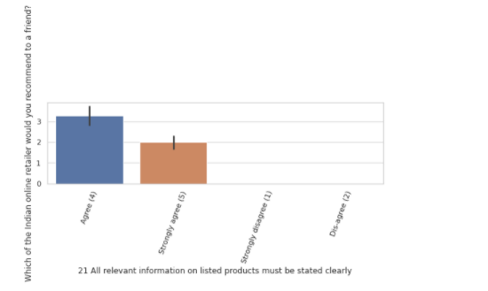

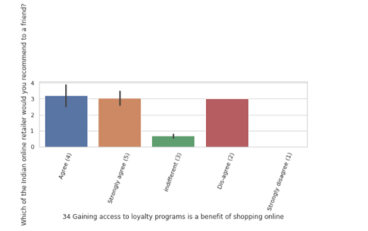

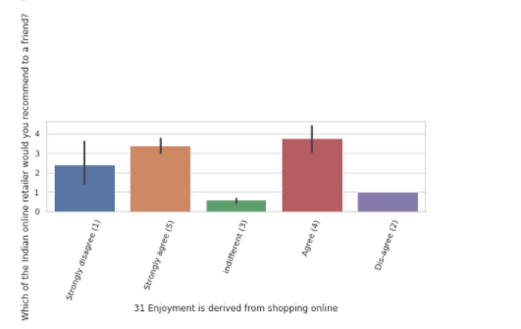

And here we have the features plots independently of the target:

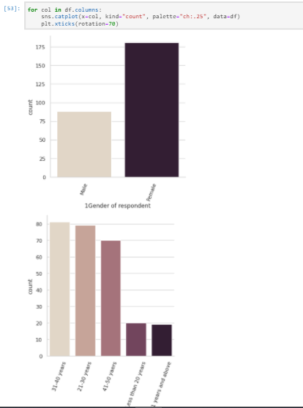

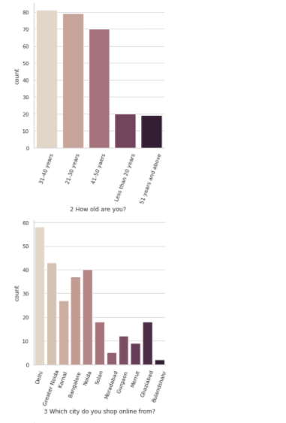

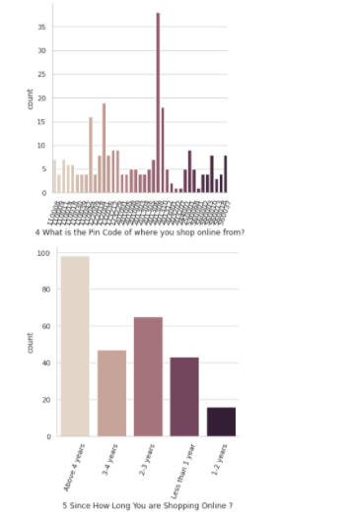

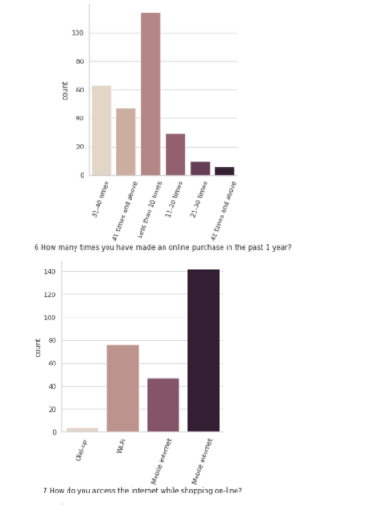

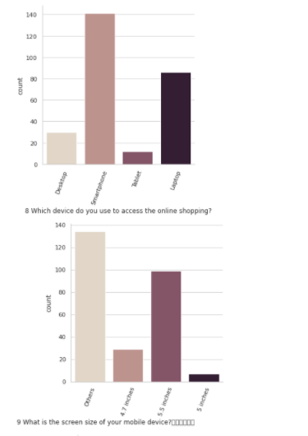

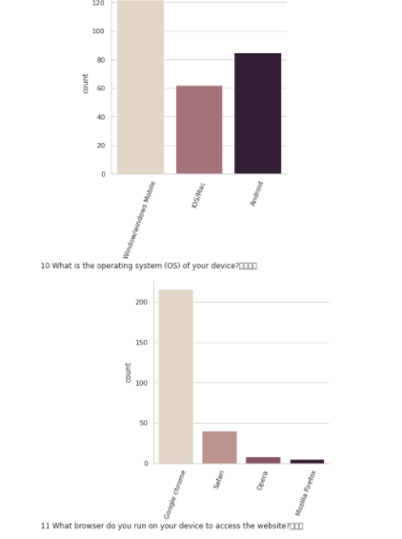

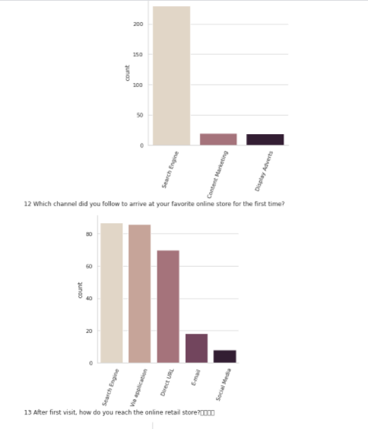

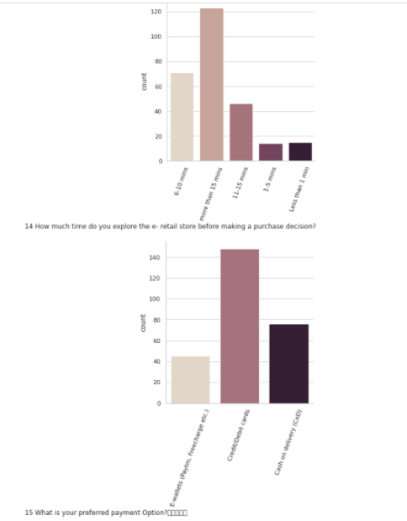

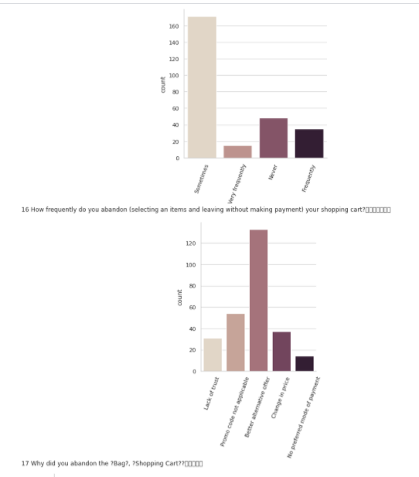

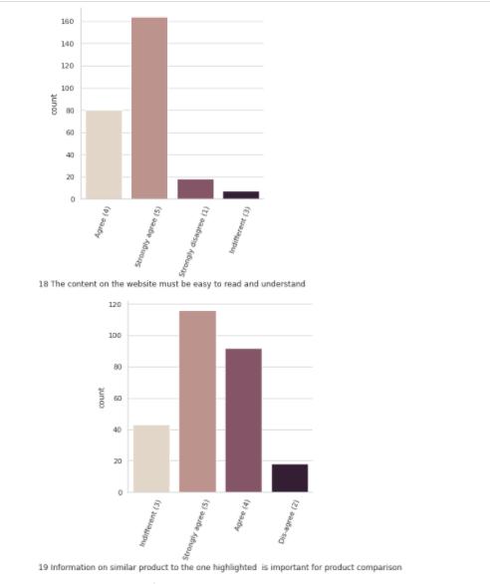

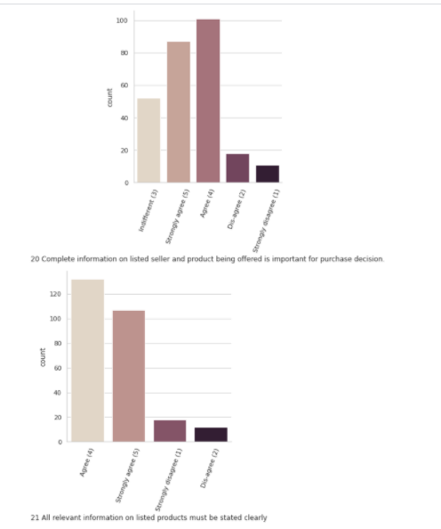

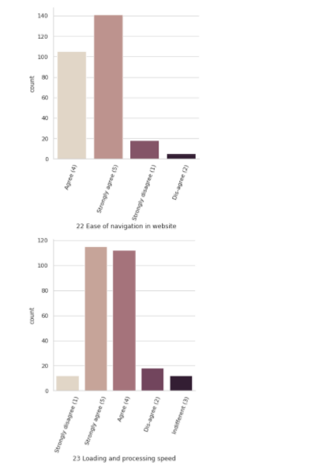

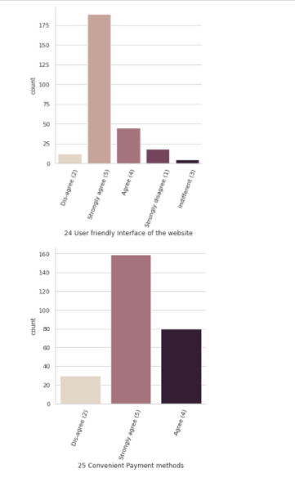

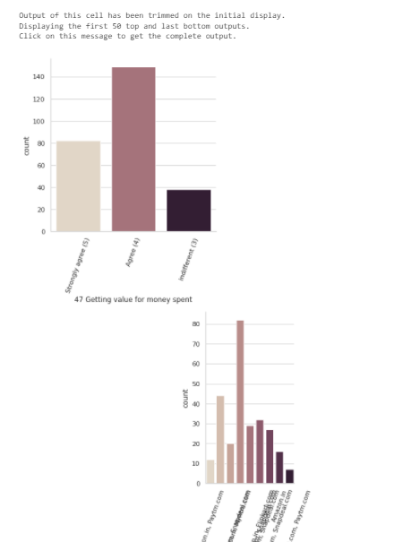

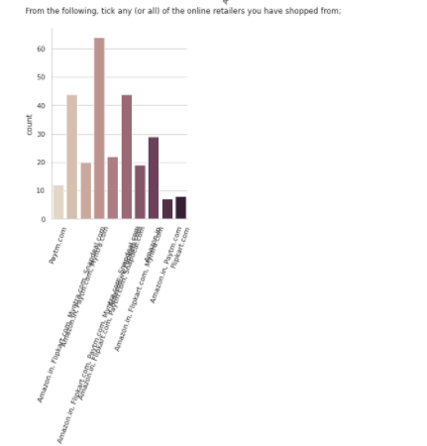

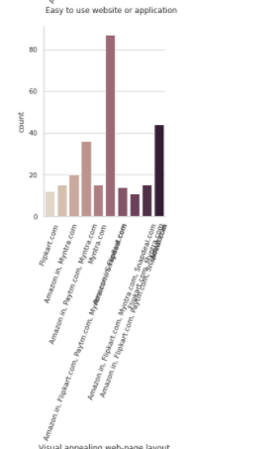

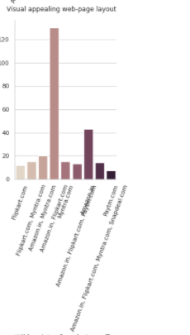

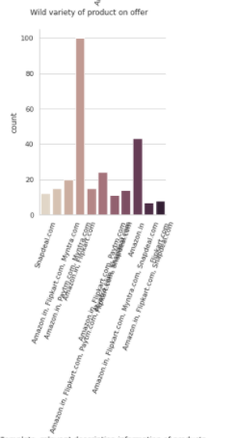

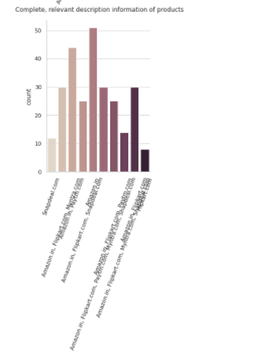

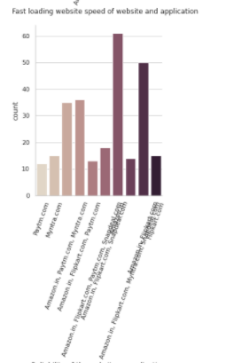

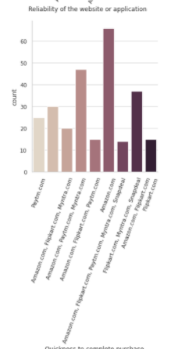

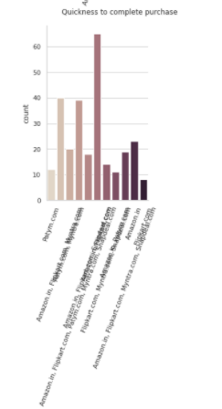

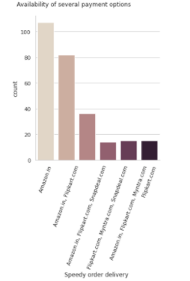

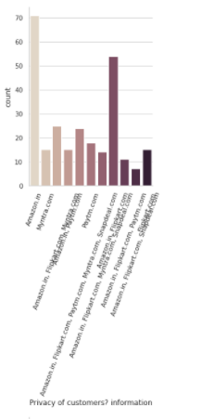

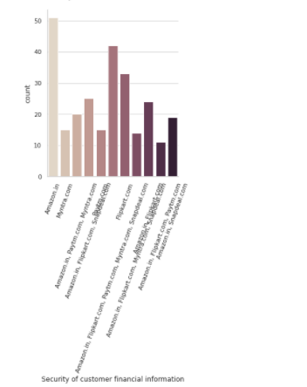

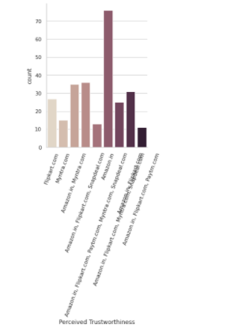

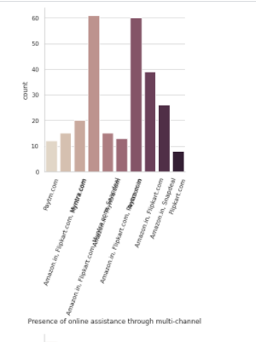

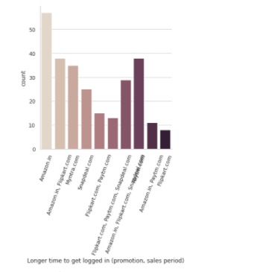

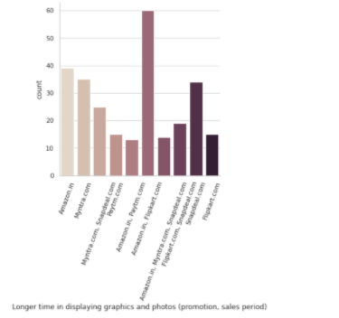

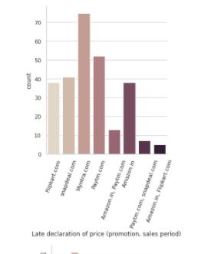

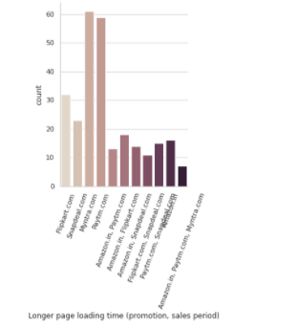

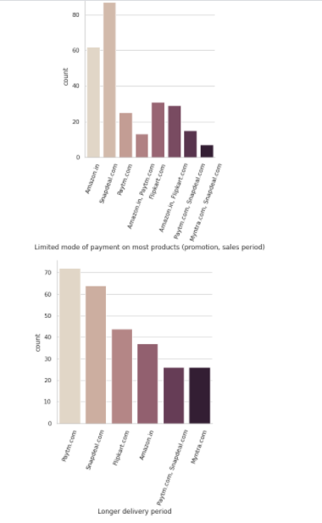

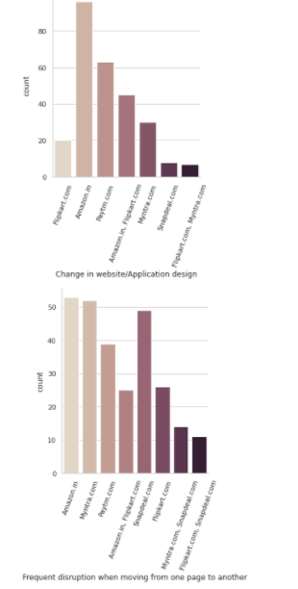

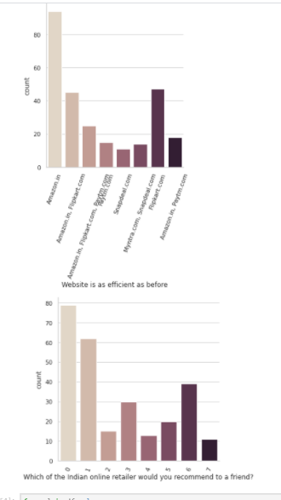

Here checking the purple plots we see the conclusion are same/Similar to the ones above mentioned.

Now moving forward with other type of plots like scatter, pointplot, stripplot, violinplot, combo of displot+boxplot, let’s see if we find some new patterns and insights.

Let’s start with scatter plot:

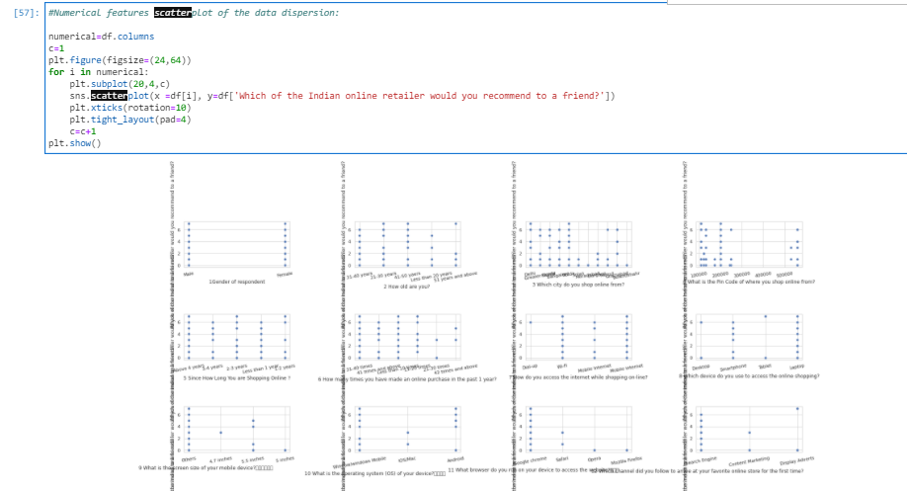

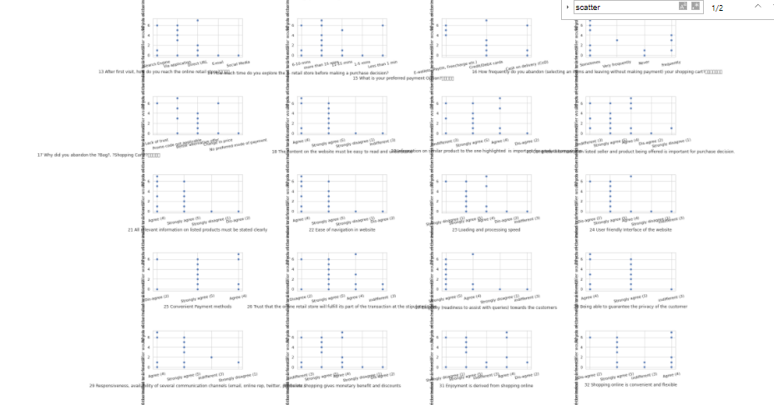

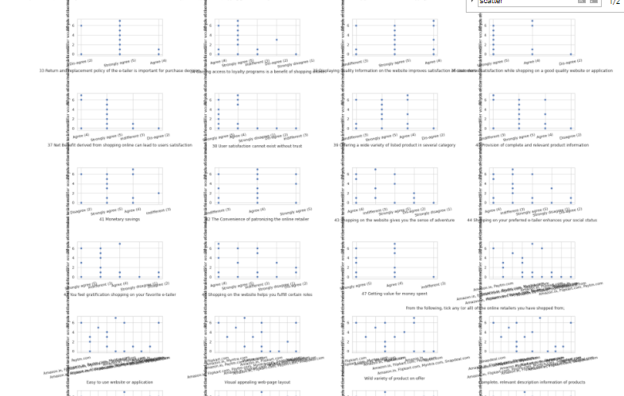

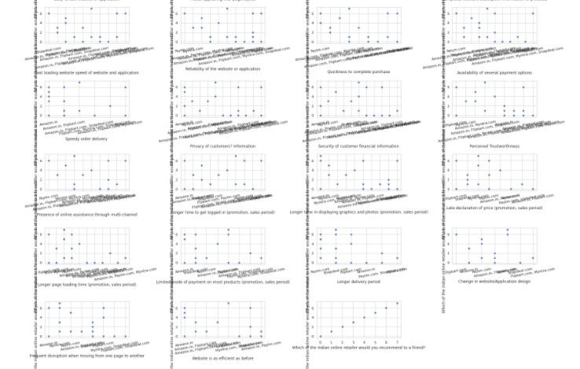

As we can see above, nothing strange can be find as scatter plots are more useful for actual numerical data and not for categorical data.

Now let’s try to plot the histogram in order to see overall data skewness:

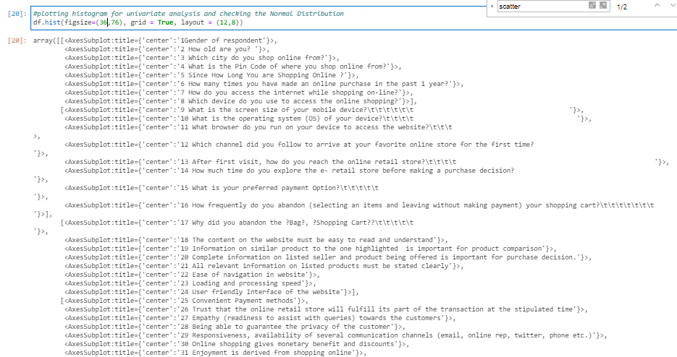

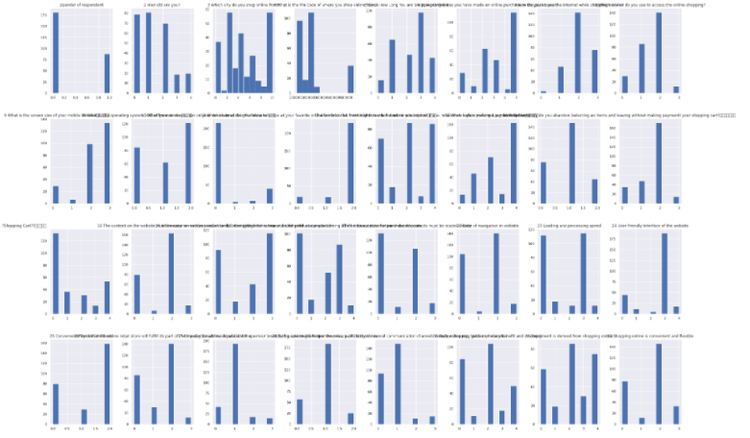

As 98,59% of the features are actually categorical data, we can check these categorical and including the 1 numerical feature as bars-plot of histogram. **A histogram can be used to show either continuous or categorical data in a bar graph.**

So, here in the above we can see some categorical features have skewness clearly seen in such as Gender of respondent, How old are you, Pin code, Size of mobile, etc. I mean all the features have skewness in its distribution as none of them have normal distribution**.**

Now let’s also check some pointplot and stripplots:

And when plotting stripplots, we see we have:

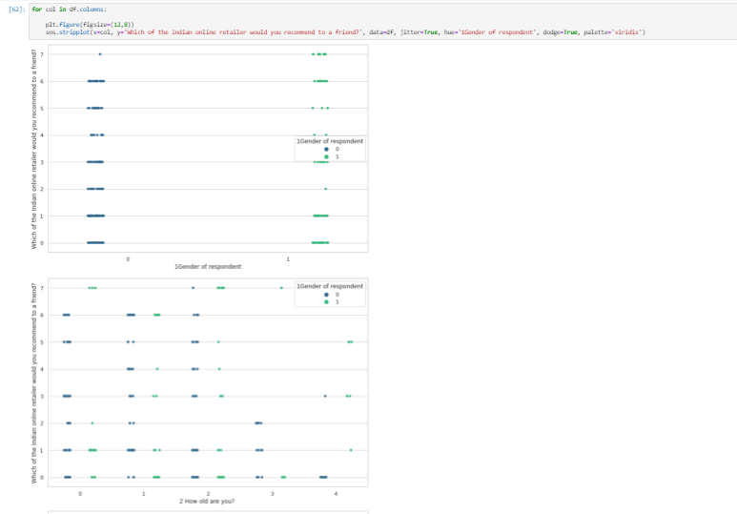

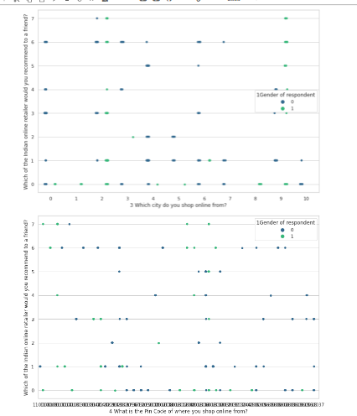

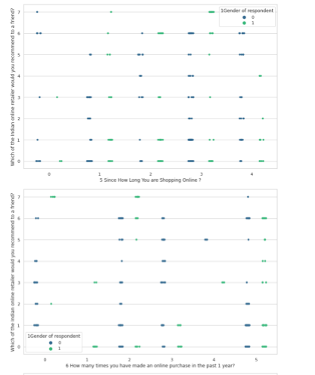

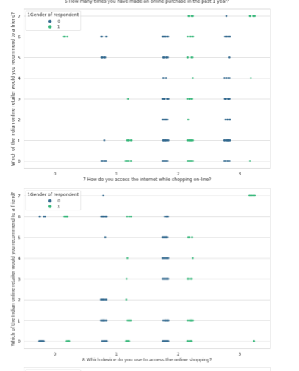

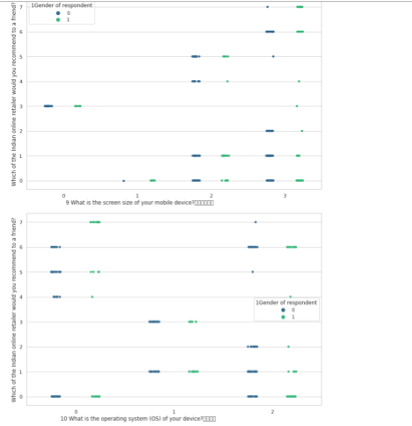

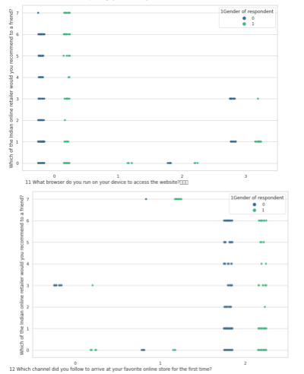

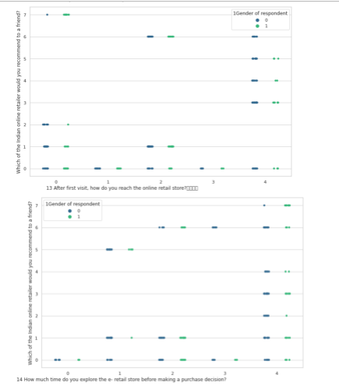

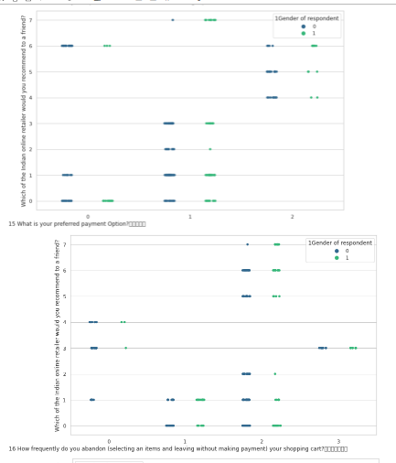

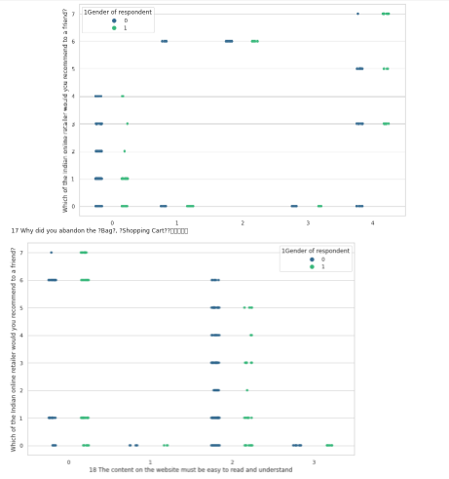

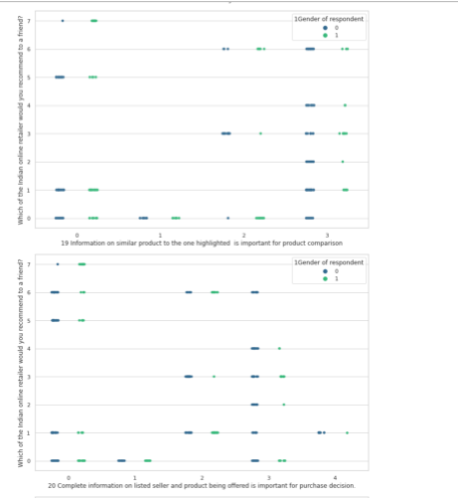

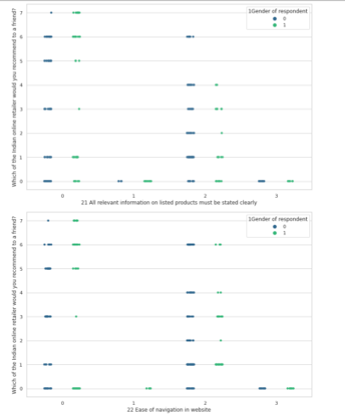

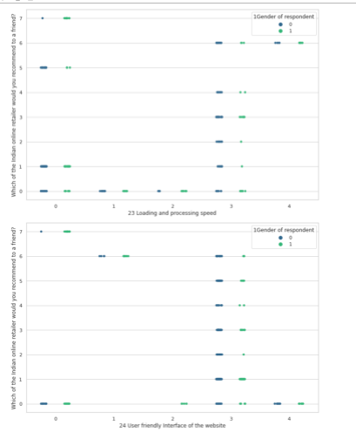

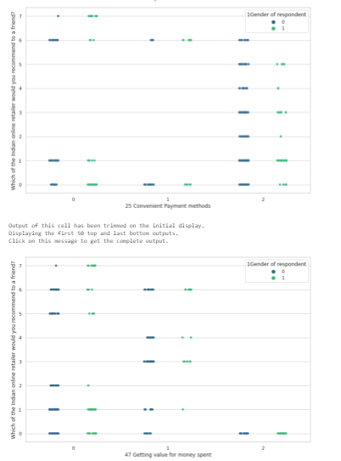

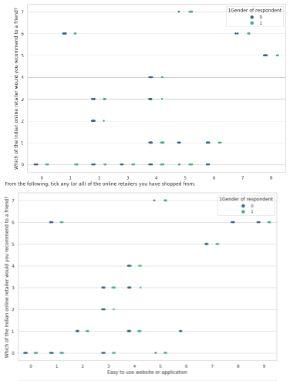

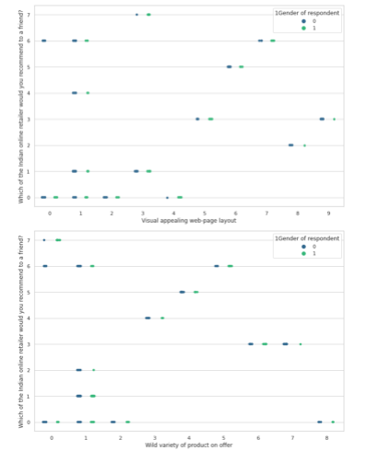

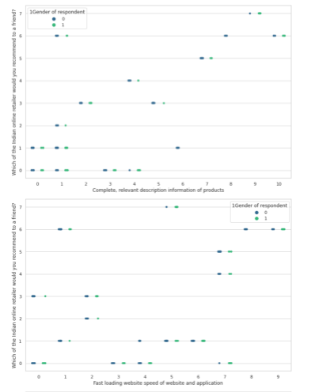

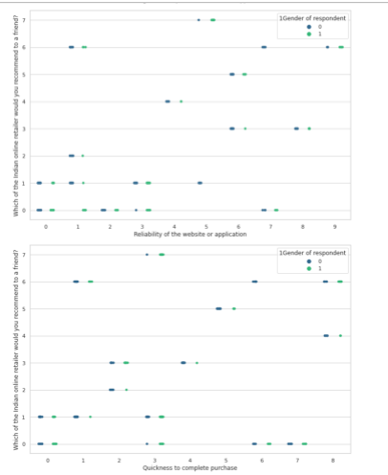

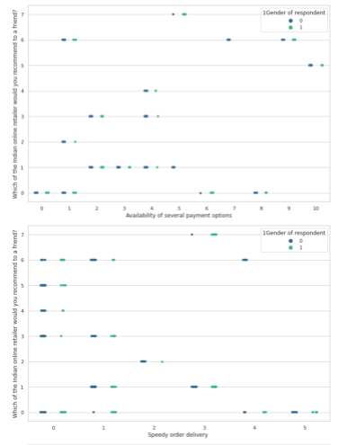

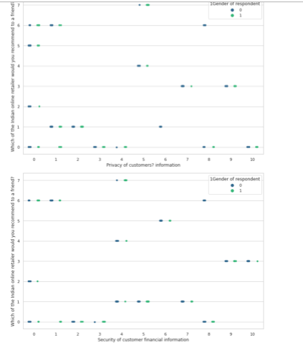

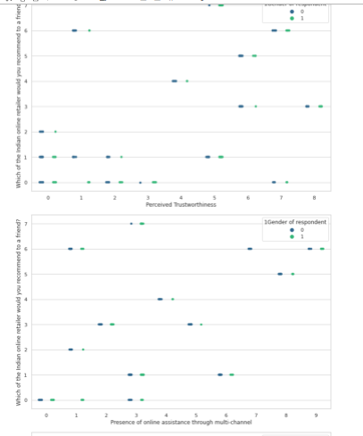

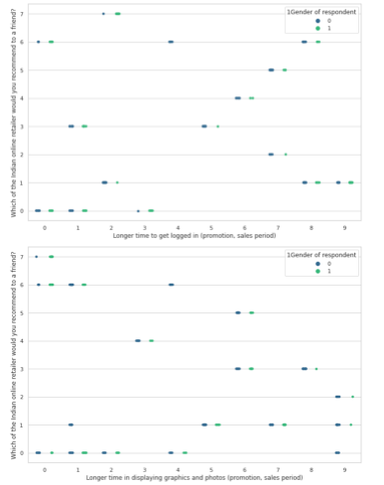

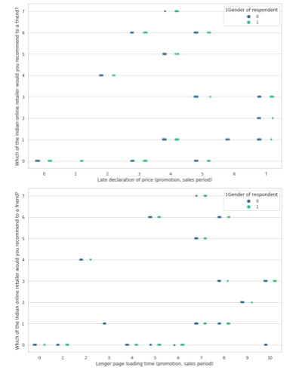

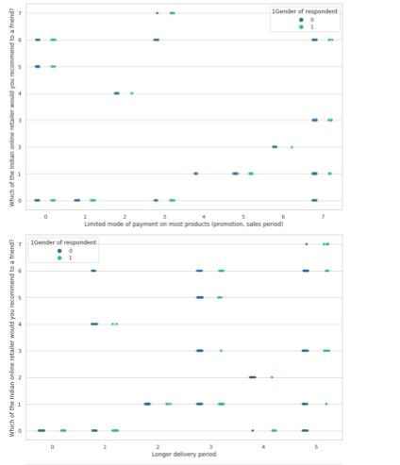

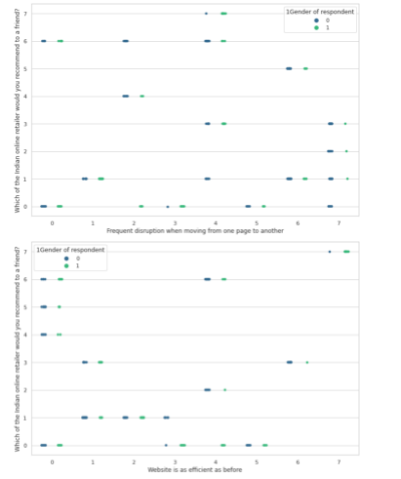

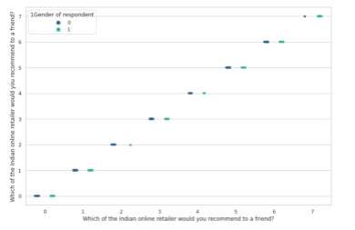

In the stripplots we see no strange pattern, looks like the remarks already done are still valid even checking these stripplots.

And when plotting point plots, we see we have:

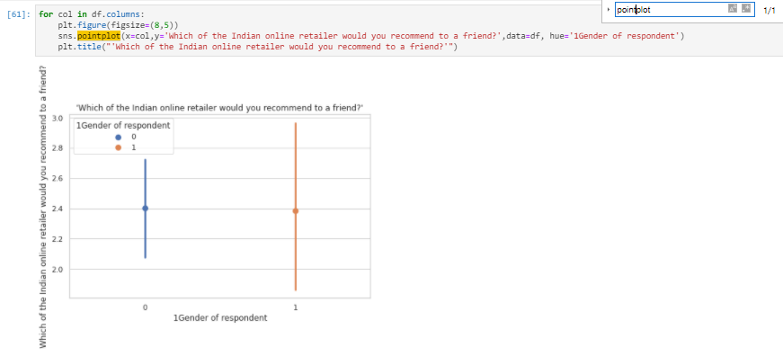

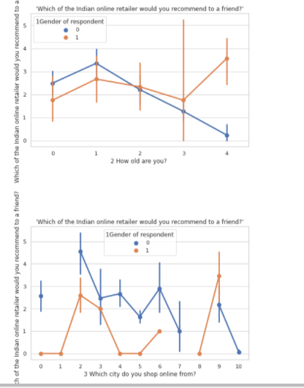

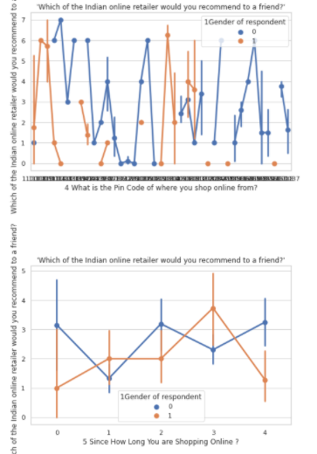

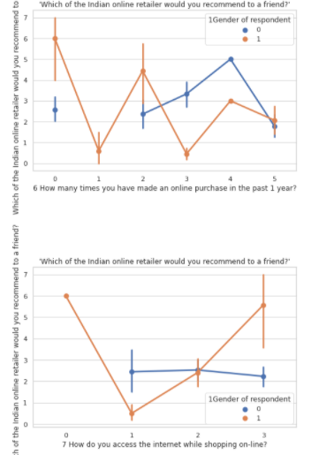

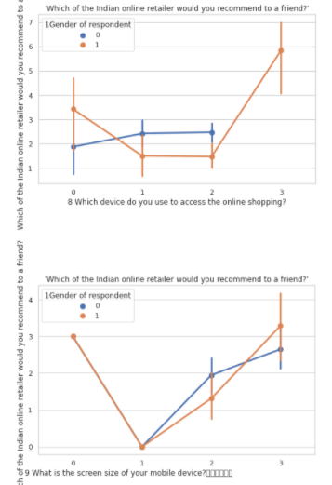

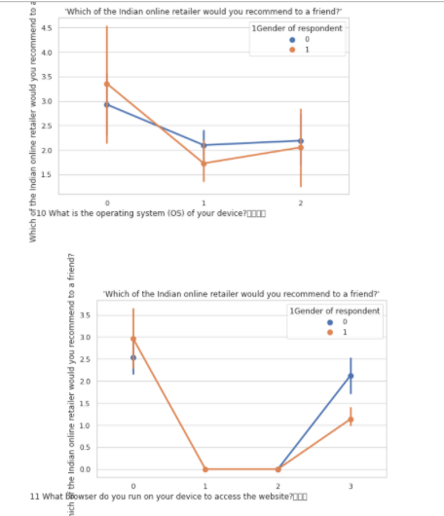

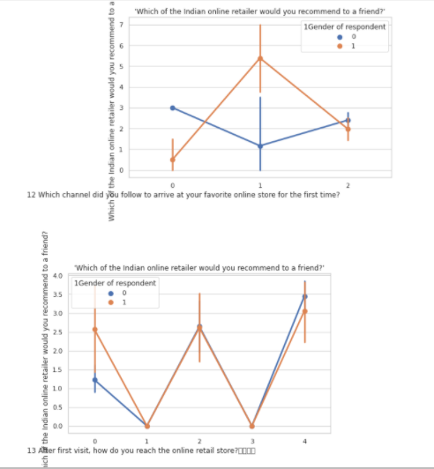

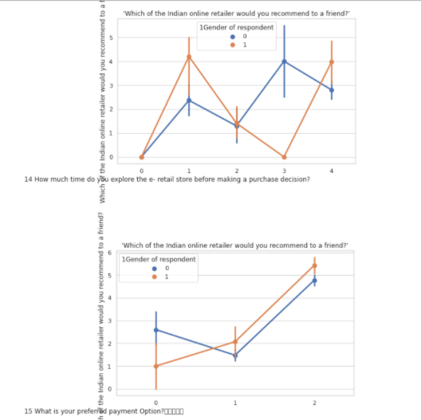

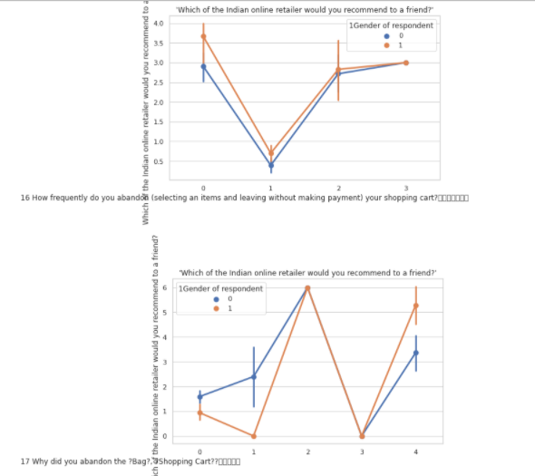

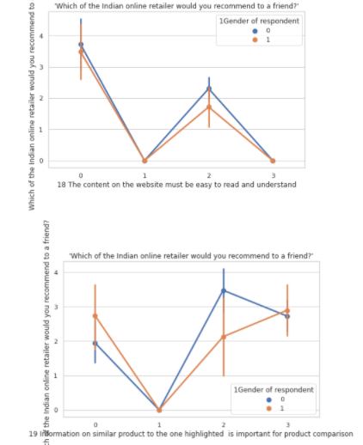

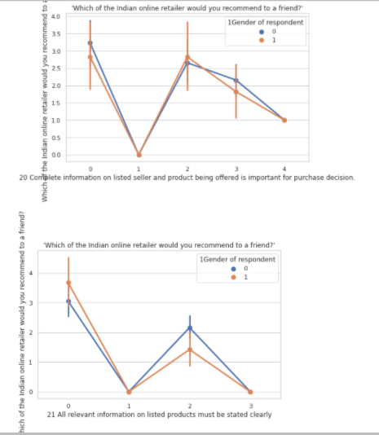

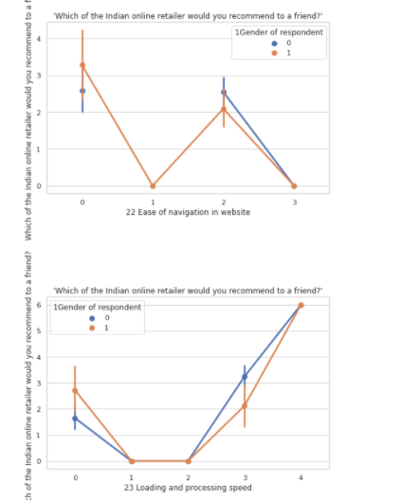

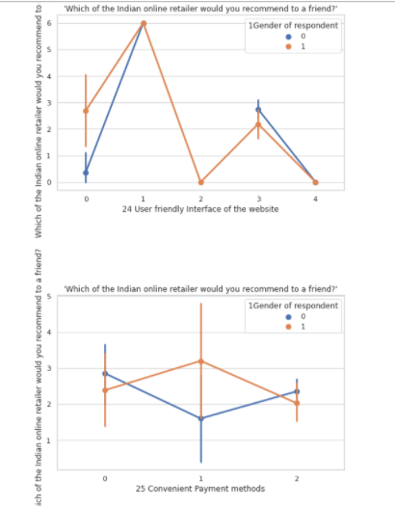

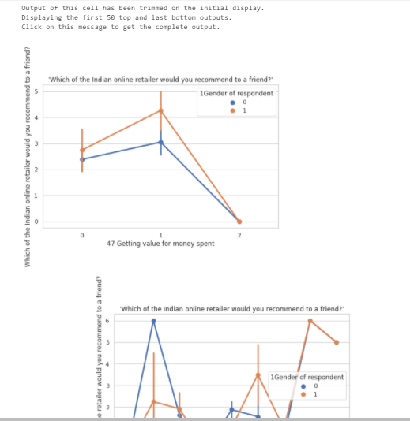

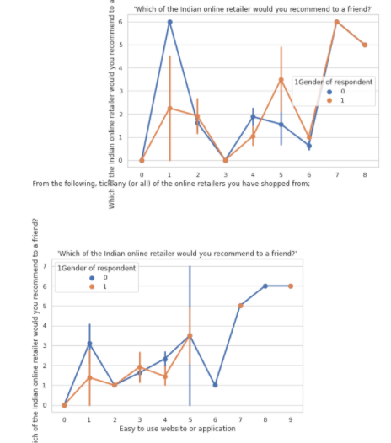

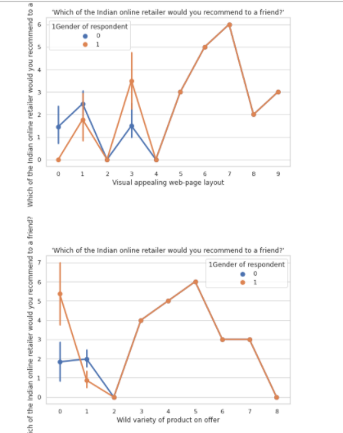

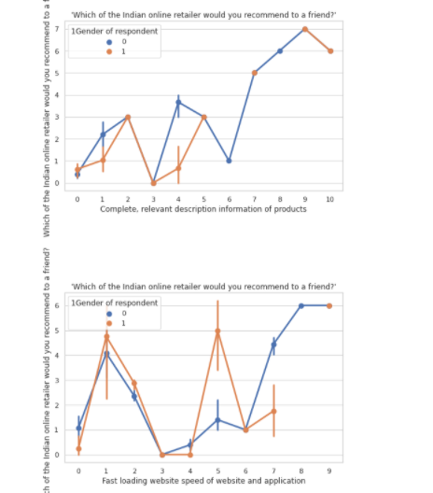

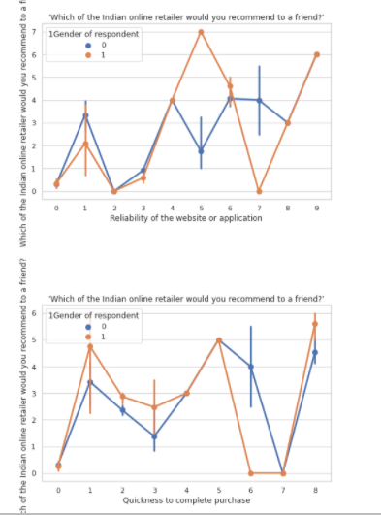

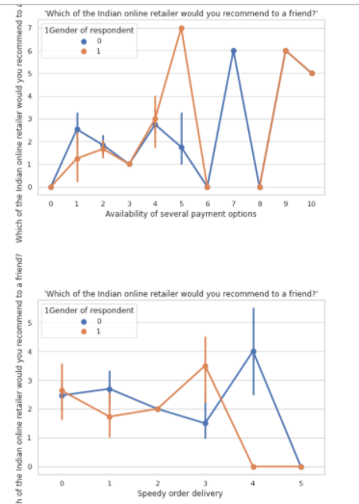

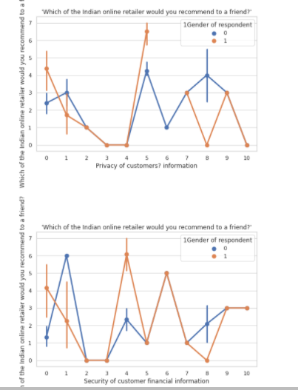

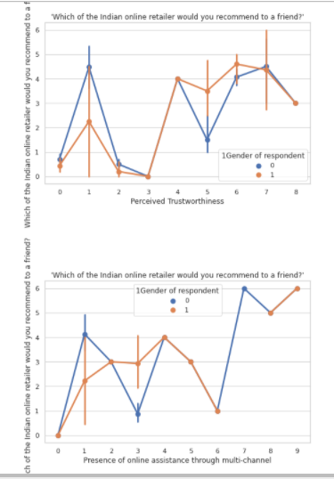

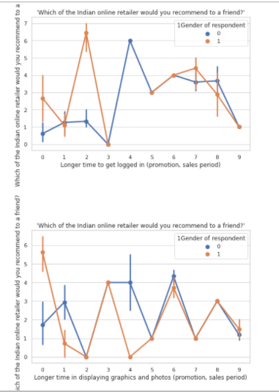

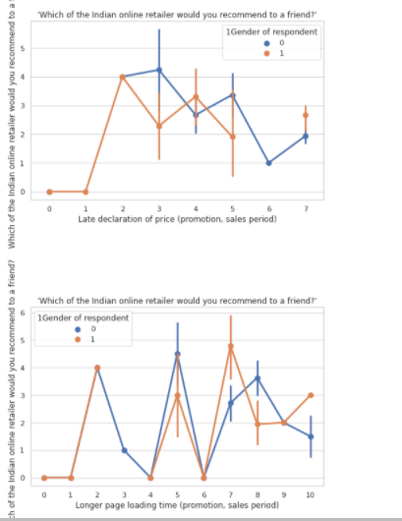

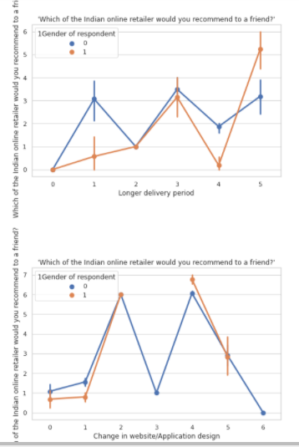

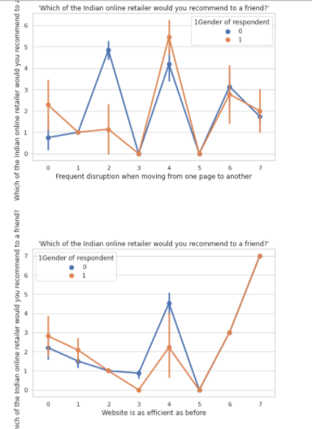

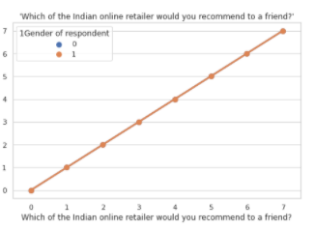

As we said, every highlight characteristic or pattern are already commented previously, so no new pattern are found. The only comments we can do here are the differences in each plot between the 2 genders: Overall, gender wise has difference pattern in each feature and it can be seen in all these pointplots.

We also plotted descriptive details of our data:

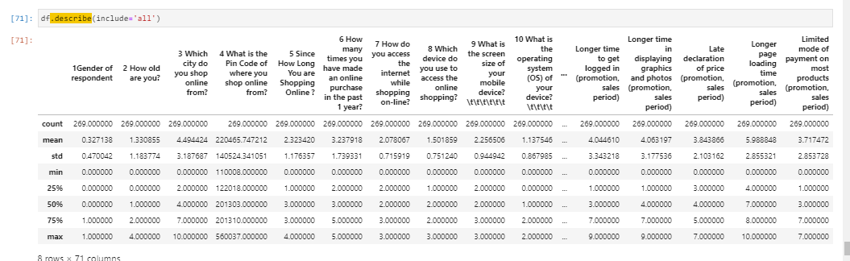

From the above describe first row, we see the count is equal to 269 which means we have no missing values as stated previously.

In general, from the above plot we could check at first sight if we had any skewness or outliers. Also checking the total number of instances, we could check and confirm that we do not have any missing values. In general, with the above plot we also can check if we have same or different scaling of the Feature. If so, apply any kind of normalization technique such as standard scaler or tmin-tmax scaler.

On the one hand, for all the Feature where the mean is smaller than the median, we can say it has left skewed data which also means negative skewness. On the other hand, if a feature has the mean higher than the median, than it is right skewed which is also called as positive skewness.

But in our case, initially all columns except one had object type data mainly because all the columns except one were categorical data type. So, what happens here is that when we have categorical data, we need to label or hot encode them in order to insert them in the machine learning algorithms. But in our case, we are not going to include our machine learning study in our report. So, basically, we are doing label encode here in order to have all Feature in our describe table in order to find or discover new pattern or statistics which maybe can help us understand better our data.

And when checking the maximum values, we see that for outlier check at first sight, we can notice it when we have larger values for the maximum compared to 75% percentile values.

We also plotted box plots for all our Feature including the target in order to check outliers in all the Feature:

­ 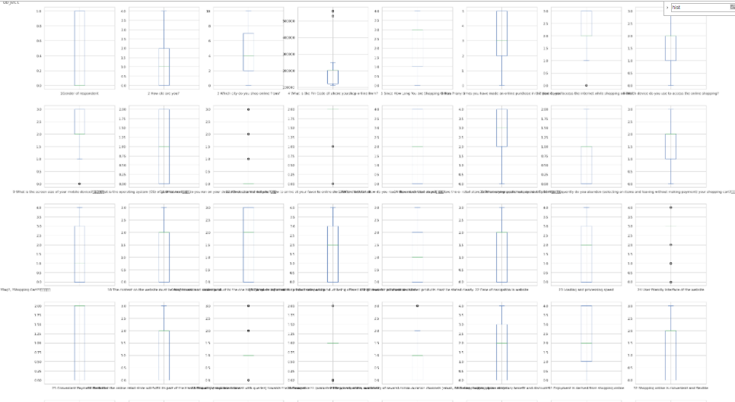

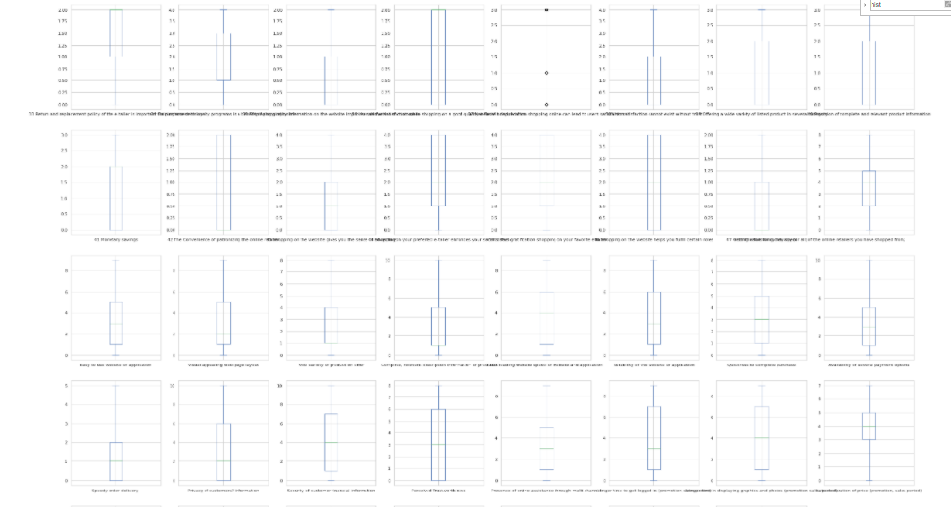

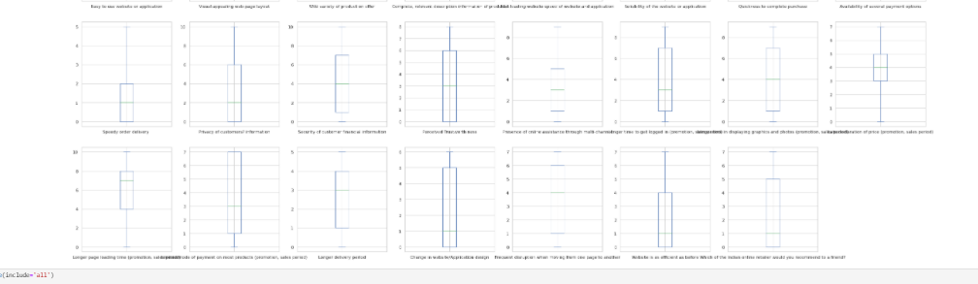

The circles are the outliers for each feature. Several Feature have outliers excluding our target variable which is one of the variables that has no outliers. We have Feature like :

37 Net Benefit derived from shopping online can lead to users satisfaction

29 Responsiveness, availability of several communication channels (email, online rep, twitter, phone etc)

28 Being able to guarantee the privacy of the customer

27 Empathy (readiness to assist with queries) towards the customers

24 User friendly Interface of the website

9 What is the screen size of your mobile device?

12 Which channel did you follow to arrive at your favorite online store for the first time?

13 After first visit, how do you reach the online retail store?

7 How do you access the internet while shopping on-line?

Now let’s check the distribution and boxplots at the same time if we can see any new pattern or findings:

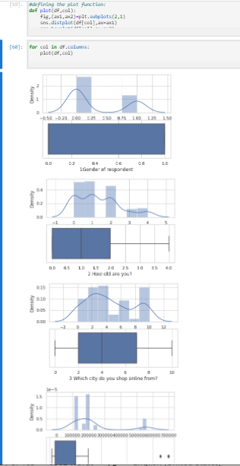

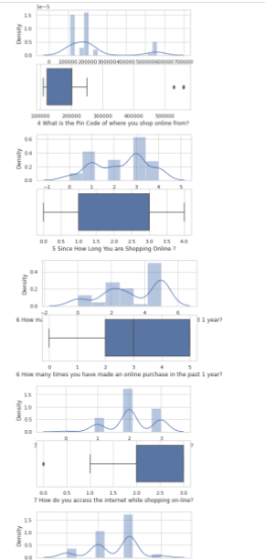

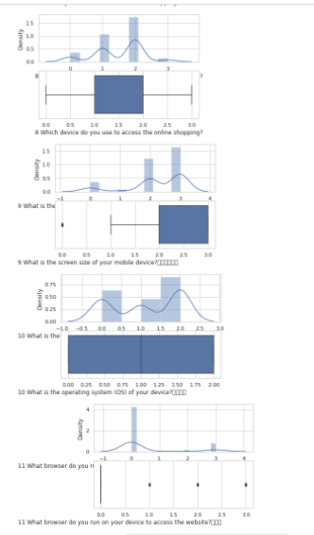

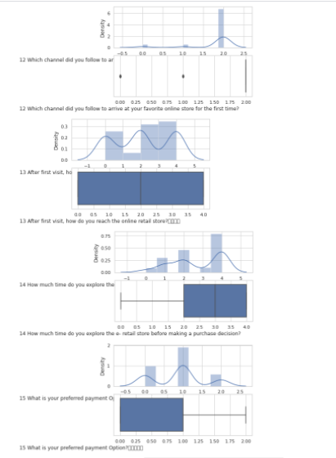

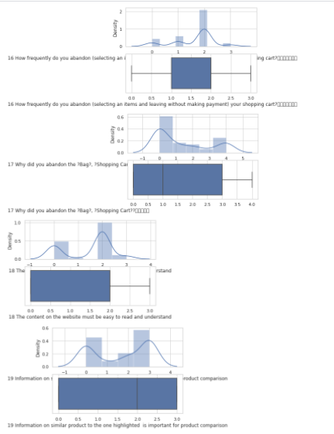

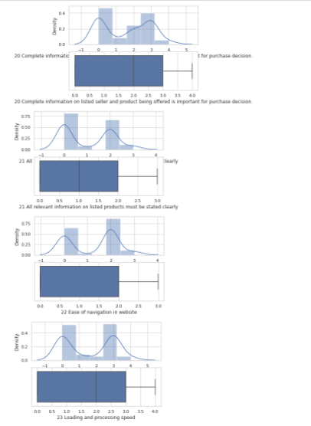

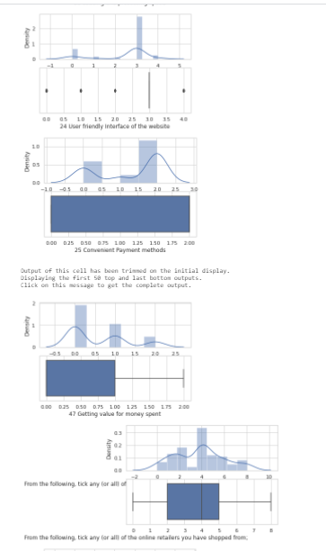

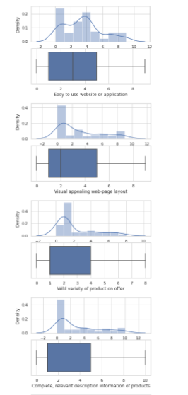

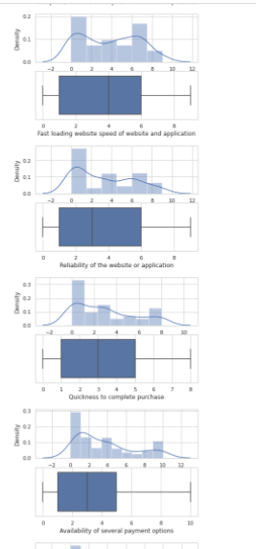

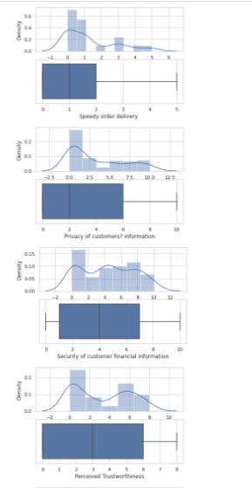

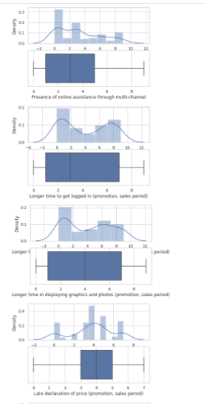

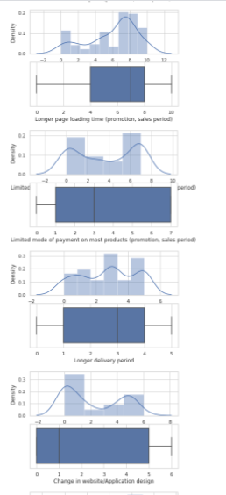

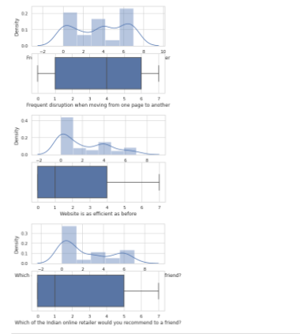

Looking at the distplot boxplot at the same time, we can highlight the following statement: As we mentioned earlier, we have distribution with skewness. There is no features with normal distribution. And regarding the boxplots, we have outliers in cases like Pin code, how do you access the internet while shopping online, what is the screen size of your mobile device?, what browser do you run on your device to access the website, which channel did you follow to arrive at your favorite online store for the first time?, user friendly interface of the website among others have outlier in its distribution, which impacts on the statistics mean, but also a little effect on the mode and median of the categorical data.

I can see the outliers more clearly in the following boxplots at once too:

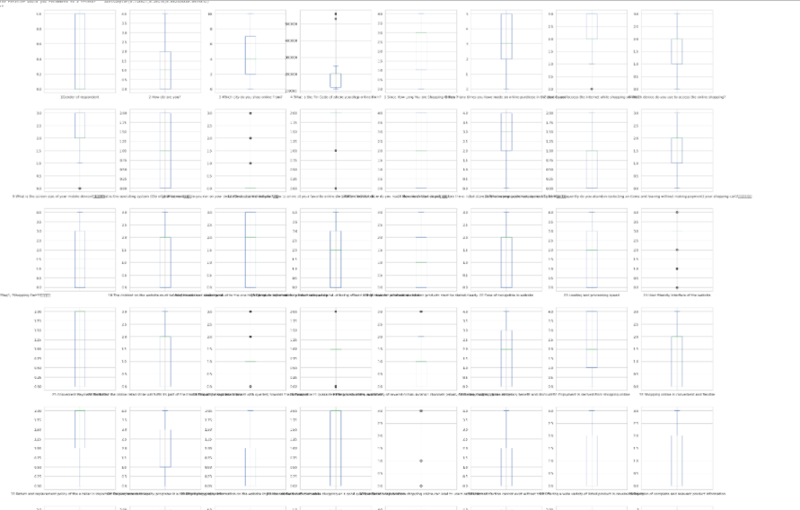

As we commented earlier, we see in the above boxplots we have outliers in some of the features such as Pin code, access to the internet while shopping, screen size of your mobile device, Which channel did you follow to arrive at your favorite online store for the first time?, After first visit, how do you reach the online retail store?, user friendly interface of the website, Empathy (readiness to assist with queries) towards the customers, Being able to guarantee the privacy of the customer, Responsiveness, availability of several communication channels (email, online rep, twitter, phone etc) , Net Benefit derived from shopping online can lead to users satisfaction, etc

Then, we also should mention the violin plots:

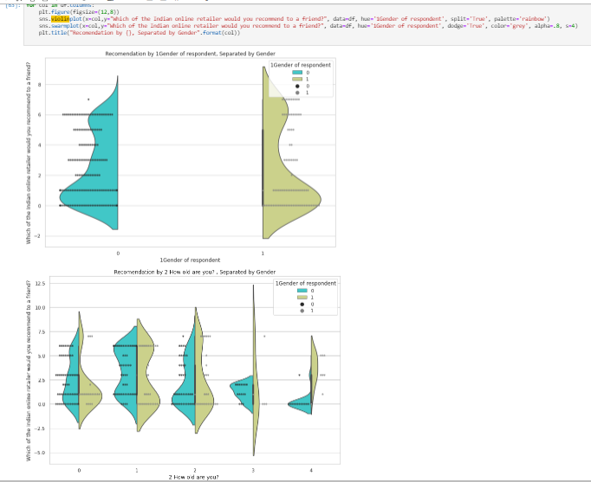

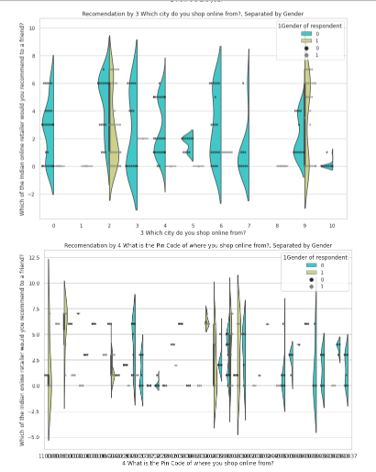

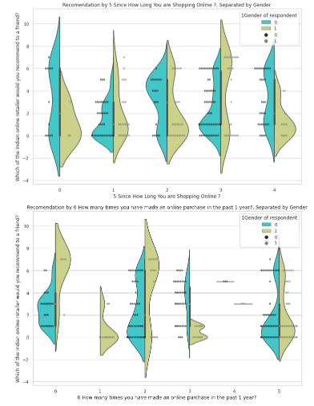

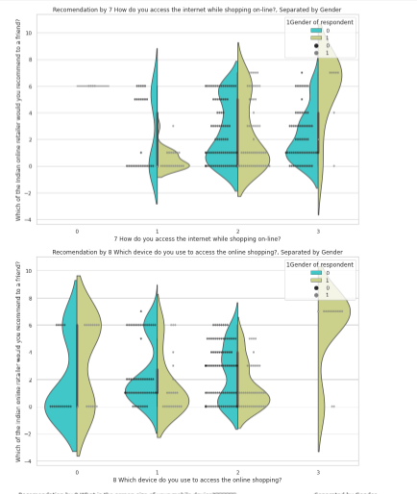

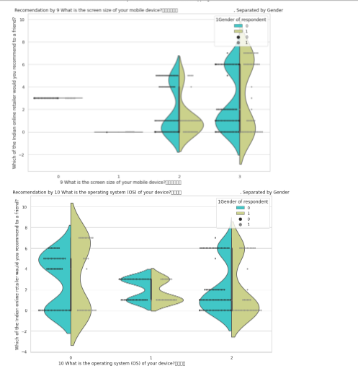

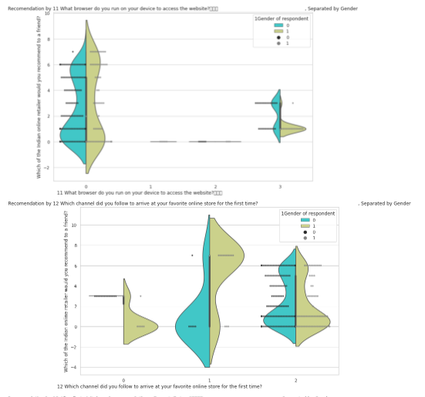

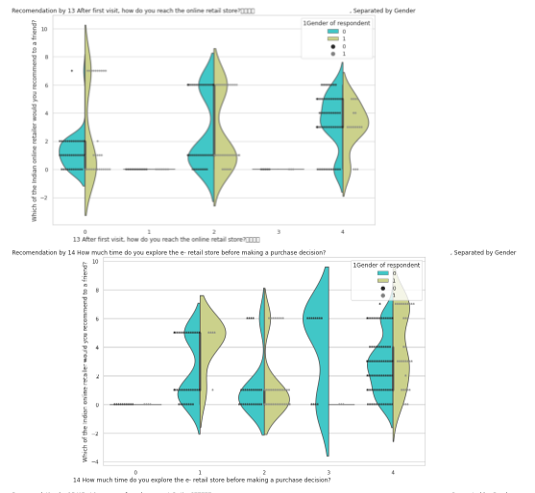

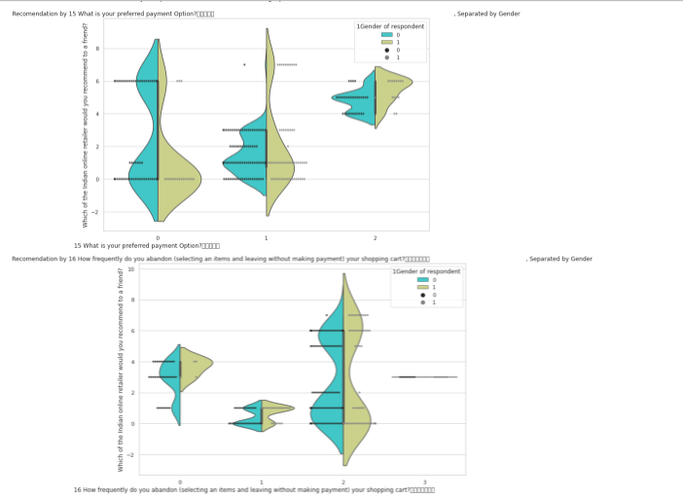

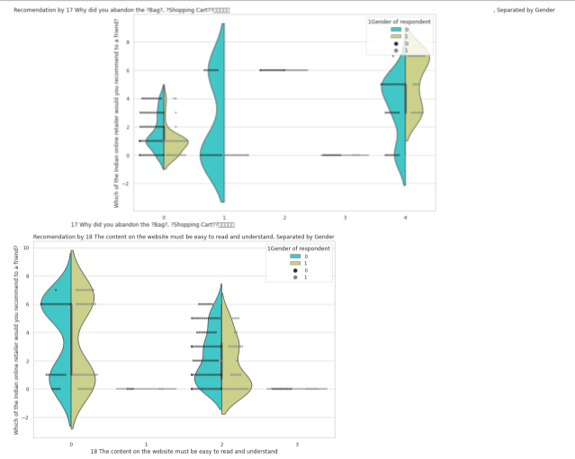

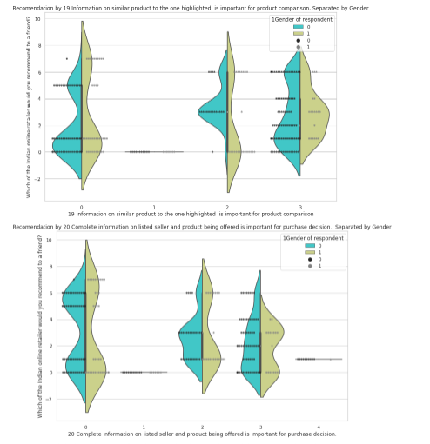

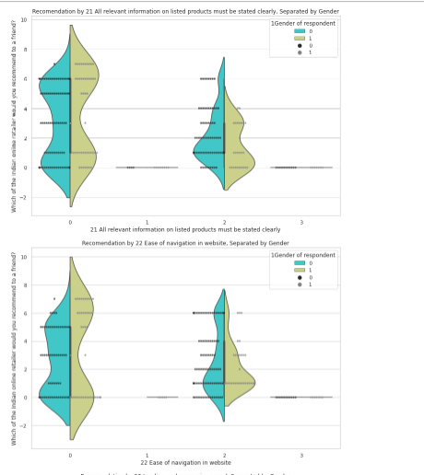

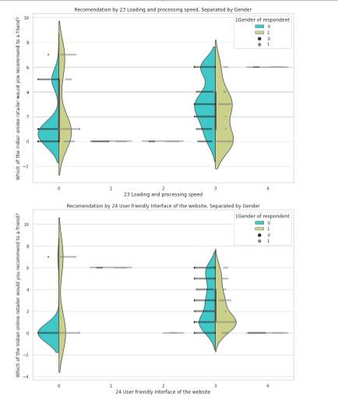

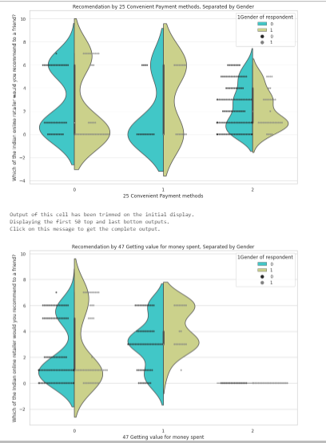

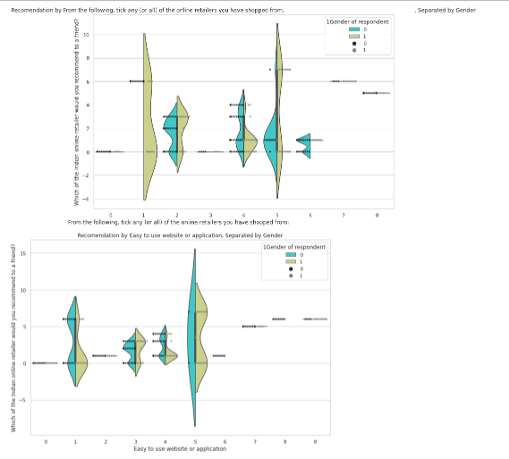

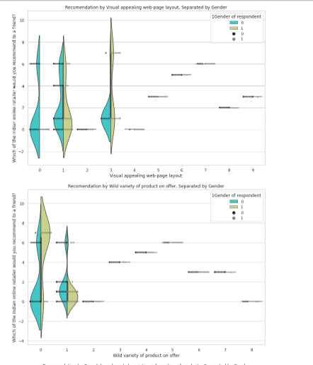

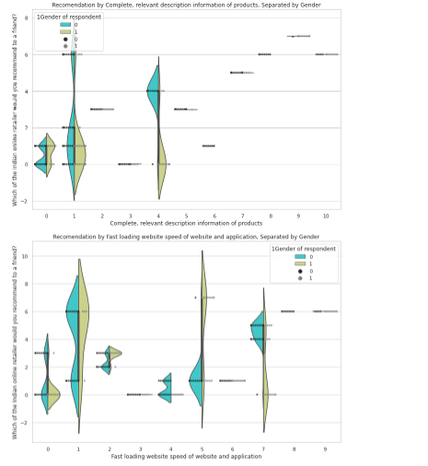

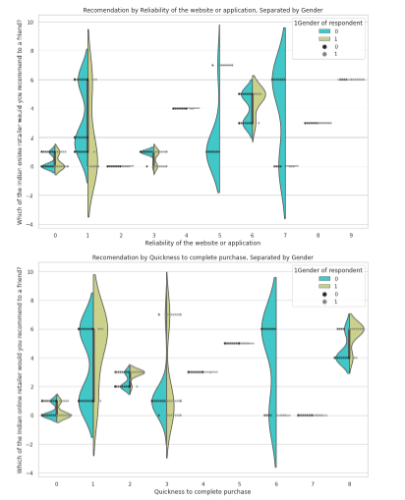

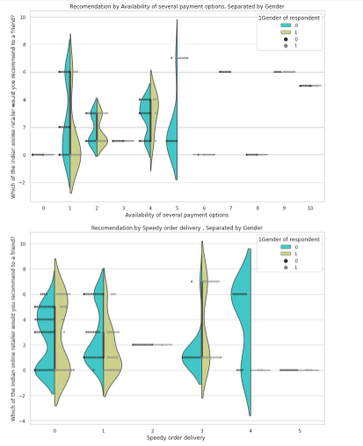

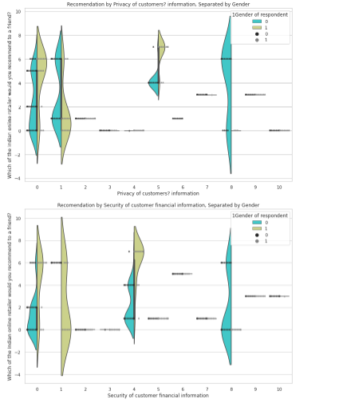

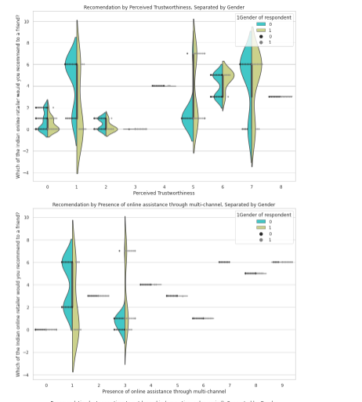

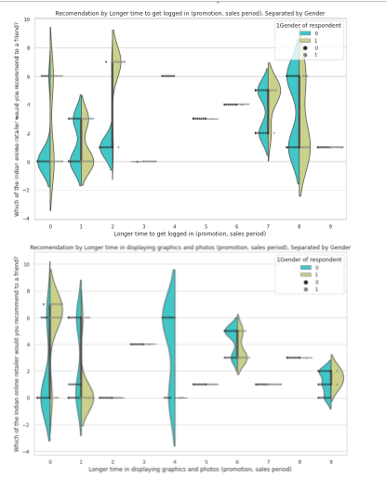

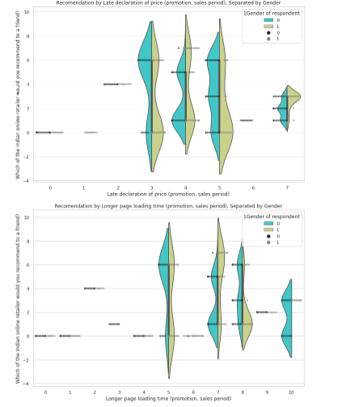

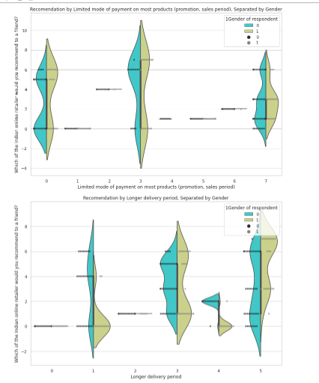

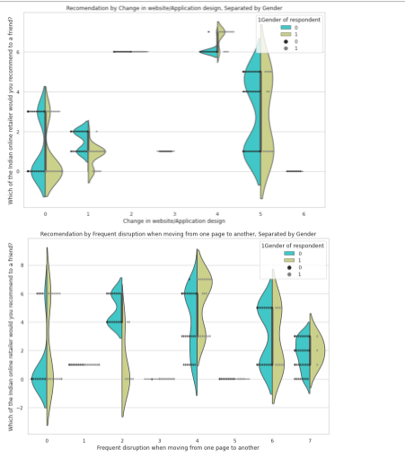

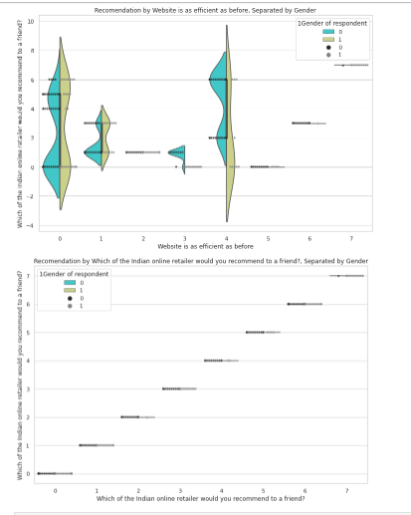

So, from the violin plots we can mention that males and females are distributed in different which can easily be check through the violinplot of “How old are you” where the label 3 and 4 have different distribution between males and females. Also, in the violin pattern of “which city do you shop online from? Where mostly the distribution is for males. Another violin plot where we can see difference between both sexes is the violin plot that shows “How many times you have made an online purchase in the past 1 year where we see label 1 has no cases of sex male and also the label 3 has male distribution throughout the violin distribution of recommendation to a friend whereas the females has a more skewed distribution and its mostly between recommendation count of -0.2 and 1.9.

Which device do you use has also a label 3 where there is no male data.

But overall, if taking all violinplots in consideration, and summarizing them, we can say that mostly all the distributions have similar cases of recommendation by males and by females.

Then, we also plotted the correlation between Feature through a heatmap in order to see easily the best correlations between all our Feature including our target “Recommendation to a friend” :

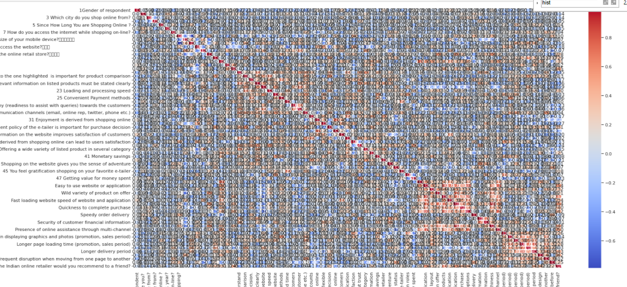

If we concentrate on the target and check the best correlations against it, then we will see that the following Feature are considered the best correlated Feature within our dataset:

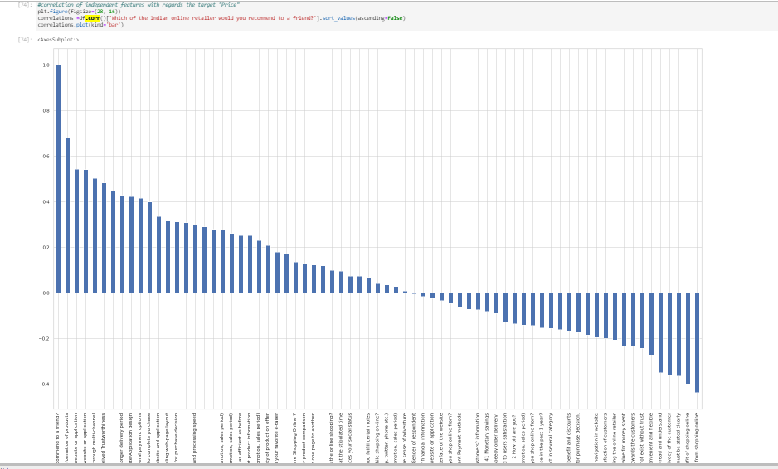

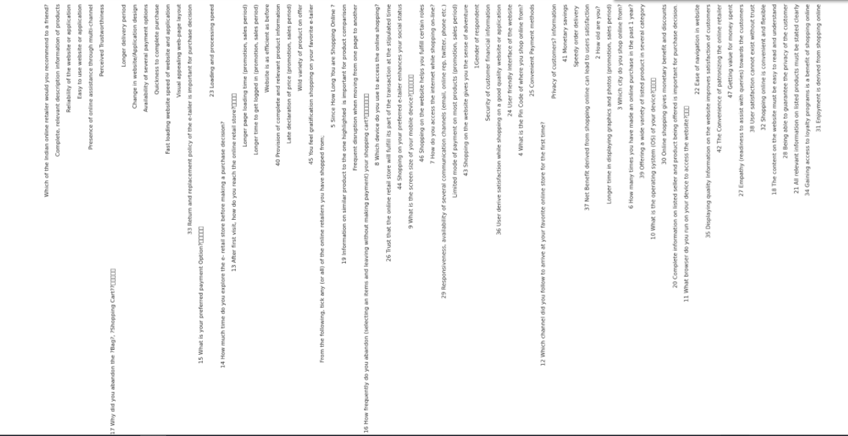

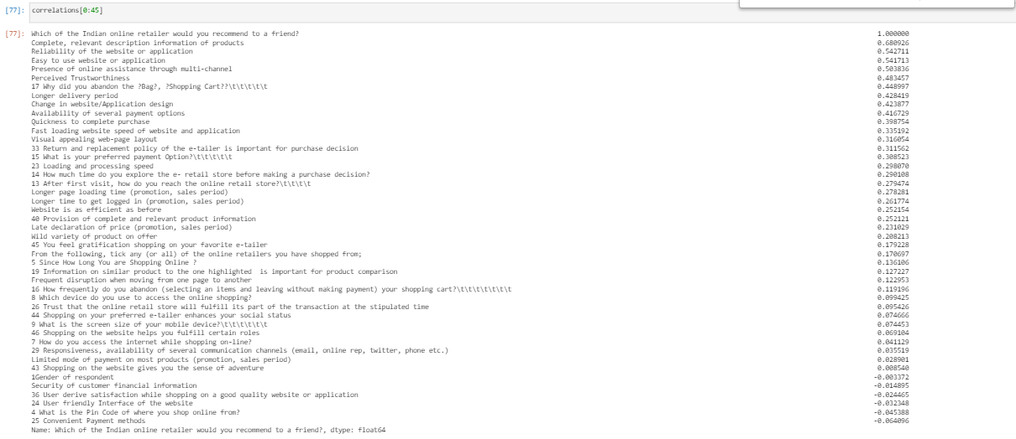

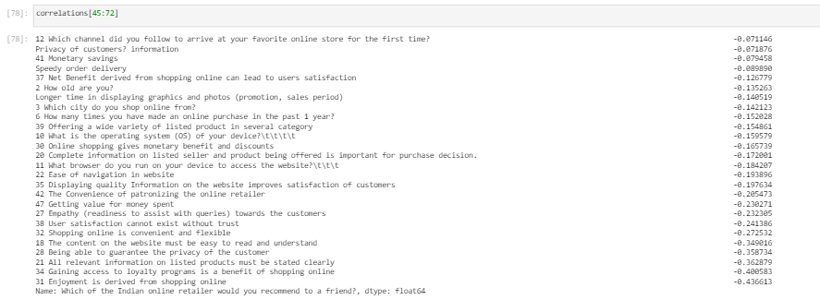

So here are the answers to the following questions:

• Which variables are important to predict if the customer will repurchase or recommend the website for ecommerce purchase?

We see several Features such as the following Features among the Features shown in the above screenshot which are the Features that have higher impact comparing all the available Features.

Complete, relevant description information of products 0.680926

Reliability of the website or application 0.542711

Easy to use website or application 0.541713

Presence of online assistance through multi-channel 0.503836

Perceived Trustworthiness 0.483457

17 Why did you abandon the ?Bag?, ?Shopping Cart??\t 0.448997

Longer delivery period 0.428419

Change in website/Application design 0.423877

Availability of several payment options 0.416729

Quickness to complete purchase 0.398754

Fast loading website speed of website and application 0.335192

Visual appealing web-page layout 0.316054

33 Return and replacement policy of the e-tailer is important for purchase decision 0.311562

15 What is your preferred payment Option?\t\t\t\t\t 0.308523

23 Loading and processing speed 0.298070

14 How much time do you explore the e- retail store before making a purchase decision? 0.290108

13 After first visit, how do you reach the online retail store?\t\t\t\t 0.279474

Longer page loading time (promotion, sales period) 0.278281

Longer time to get logged in (promotion, sales period) 0.261774

Website is as efficient as before 0.252154

40 Provision of complete and relevant product information 0.252121

Late declaration of price (promotion, sales period) 0.231029

Wild variety of product on offer 0.208213

And from negative side, we have:

42 The Convenience of patronizing the online retailer -0.205473

47 Getting value for money spent -0.230271

27 Empathy (readiness to assist with queries) towards the customers -0.232305

38 User satisfaction cannot exist without trust -0.241386

32 Shopping online is convenient and flexible -0.272532

18 The content on the website must be easy to read and understand -0.349016

28 Being able to guarantee the privacy of the customer -0.358734

21 All relevant information on listed products must be stated clearly -0.362879

34 Gaining access to loyalty programs is a benefit of shopping online -0.400583

31 Enjoyment is derived from shopping online -0.436613

• How do these variables describe the recommendation of purchase or repurchase of customer and hence the retention of the customer?

These variables have higher impact on the target then the others when comparing the percentage of correlation. So, the higher correlation, more probability to have higher impact on the decision of recommending to a friend.

Looking at the above pairplot, we see some Feature have linear relationship between them and others not that linear.

And finally, we did the following histograms in order to check the skewness of the data:

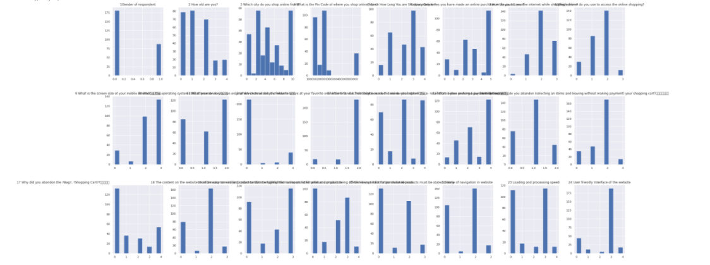

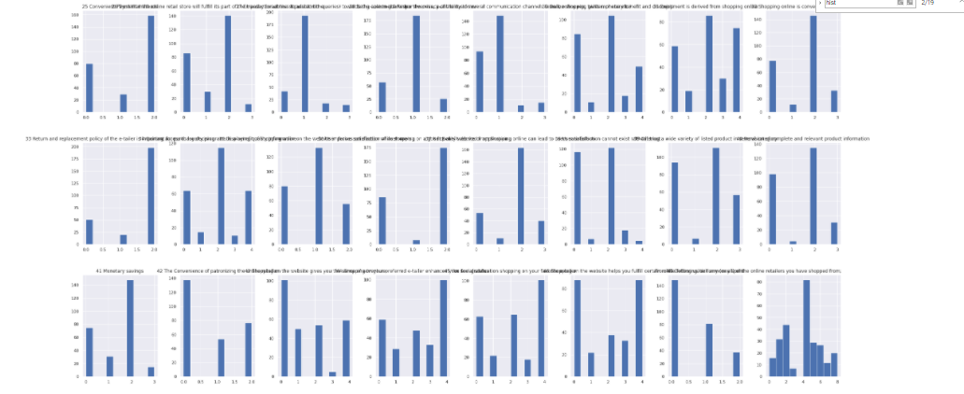

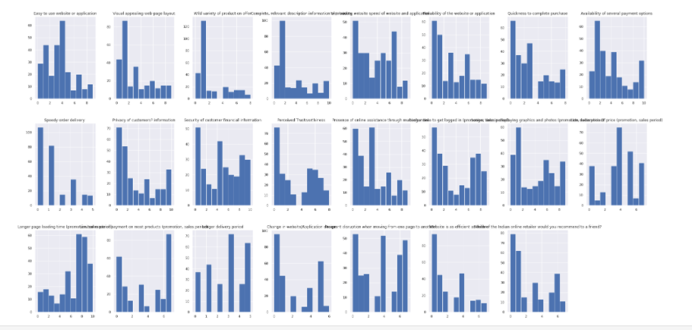

Here we see that almost all the Feature have some kind of skewness as these are not statically balanced and not having medium=mode=mean. In some of the Feature we have skewness either on the right side or on the left side.

* Interpretation of the Results

First of all, we did not need to manage any of the missing values by imputing them either with mode or mean of the same feature.

Then, we had skewness, multicollinearity and outliers that we had in some of the columns.

Then, after analysing several different visualizations, pre-processing and modelling, we got the following results:

In machine learning, it is a general practice to rely on a correlation matrix to decide what Feature to be incorporated into our models. We noticed we had several Feature such as Complete, relevant description information of products, Reliability of the website or application, Easy to use website or application, Presence of online assistance through multi-channel, Trustworthiness, Why did you abandon the ?Bag?, ?Shopping Cart?? among the Feature which are the Features that have higher impact comparing all the available Features as follows:



These variables have higher impact on the target then the others when comparing the percentage of correlation. So, the higher correlation, more probability to have higher impact.

I deleted the ML part as I could not add it to one python script as I can’t upload python script to github for more than 25kb of memory. The other reason is that I can not provide more than 1 script for the project, so finally decided to get ride of ML part finally in the last minute (and also I need to comment here in the last minute that I may have uploaded the project before the extended deadline if I was not concentrated on the ML part and had known that i would not be able to upload it to github, but anyway, no worries!).

* Learning Outcomes of the Study in respect of Data Science

As we may know improvement in computer technology has made it possible data that cannot previously be captured, processed and analysed such as customer retention strategy research. This study is an attempt to use machine learning algorithms in estimating the customer recommendation on the ecommerce purchare or repurchase, and then compare their results.

As I am not including the ML part for several technical reasons, anyway as general thought that was also included in the last project for Flipnwork first ML project I think we should suggest that the choice of algorithm depends on several factors including, the size of data set, computing power, time constraint and researcher’s knowledge about machine learning. Needless to say, it is a good practice to use more than one algorithm to compare the predictions.

Ok fin, ya!!